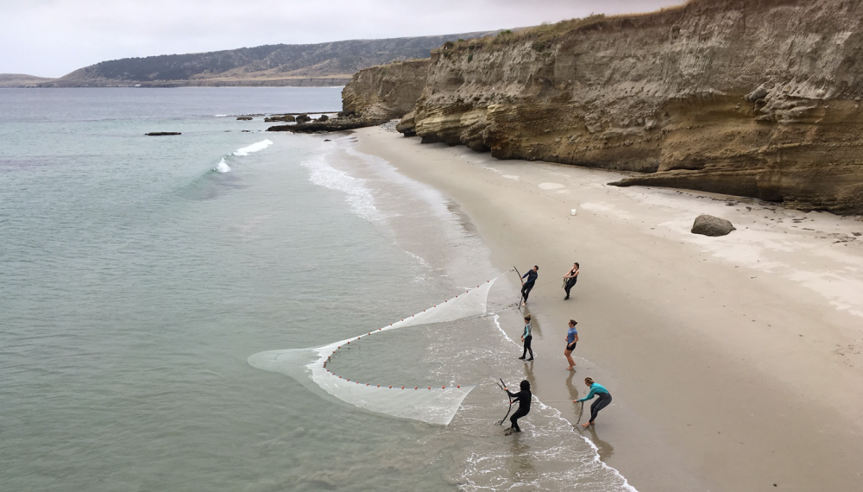
Crisis Management Plan
(FIELD OPERATIONS)

The following outline is adapted from the crisis management protocol used by NOLS (National Outdoor Leadership School).
It is intended to provide a management framework for campus/departmental response.
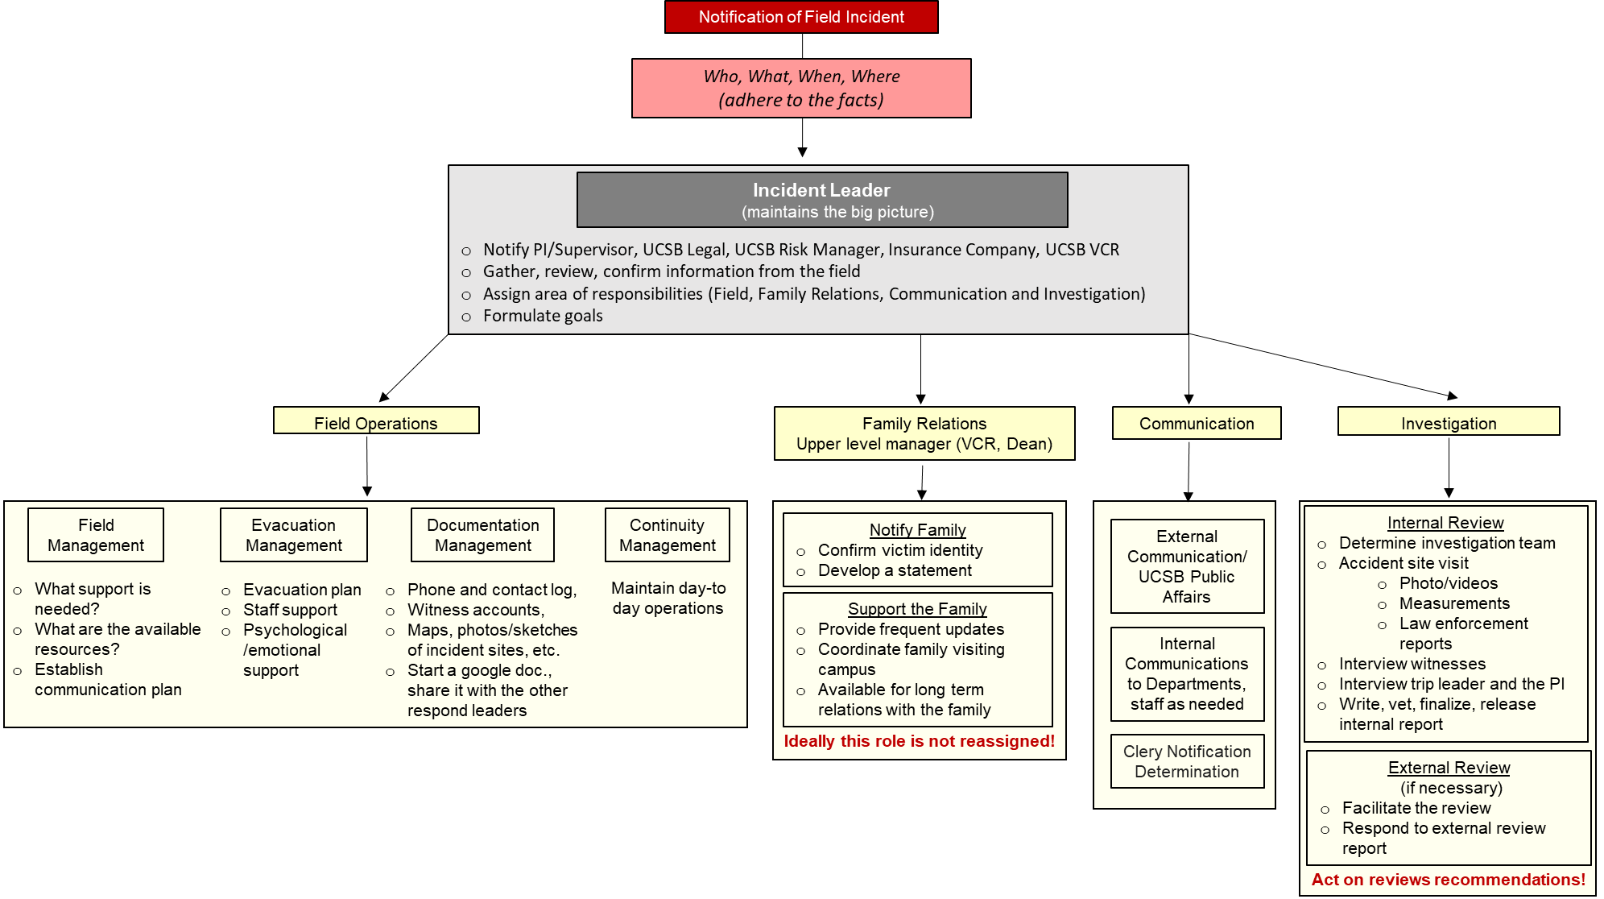
CRISIS RESPONSE FLOWCHART AND CHECKLIST:
IN THE FIELD:
Crisis in the field is a serious incident:
- Fatality
- Serious injury (threat to life or limb)
- Serious illness (threat to life)
- Major environmental or political disturbance (flood, fire, earthquake, terrorism, etc.)
During a crisis in the field contact:
Role | Main Contact | Secondary Contact | Back up
Principal Investigator
Department Chair or MSO
EH&S Director
UC Travel Insurance | 24/7 numbers:  1-800-527-0218 (US)  1-410-453-6300 (outside US call collect) | 1-866-451-7606 (From U.S. and Canada)  1-410-453-6330 (From outside the U.S.) | Campus Risk Manager:

In case of crisis initiate first aid respond and emergency procedures. Contact the numbers above and report:
- Who -
- What
- When
- Where
The report should be concise and factual.

ON CAMPUS:
Once notification of a crisis in the field comes in, initiate a response within the first hours following the flow chart and checklist on page 2.
Suggested Incident Leaders:  EH&S Director  EH&S Research Safety Manager  Department Chair and/or Chair of appropriate committee | Suggested Family Relations Leader:  Associate Vice Chancellor of Research  College Dean  Director of Finance & Administration, Academic Affairs
Suggested Field Operations Leader:  Lab Manager:  Dive and Boat Safety Officer Eric Hessel 805-451-5099  Field Safety Officer Nelly Traitcheva 805-680-2118 | Suggested Communication Leader:  Department MSO  Office of Research
Suggested Incident Investigator:
Appropriate Committee or Control Board and Experienced field researcher familiar with the victims work
Important phone numbers:
Role | Main Contact | Secondary Contact | Back up
EH&S Director
Campus Risk Manager
EH&S Field Safety Officer
EH&S Dive Safety Officer
Family Relations
Chief Campus Counsel (Legal)
Public Affairs
Clery Notification Coordinator |  |  | UCPD:
UC Travel Insurance | 24/7 numbers:  1-800-527-0218 (US)  1-410-453-6300 (outside US call collect) | 1-410-453-6330 (From outside the U.S.)  1-866-451-7606 (From U.S. and Canada) | Campus Risk Manager:
UCPD
CAPS (Counseling & Psychological Services 24/7): |  | Employee Assistance Program:
Title IX
Student Health | 24hr Nurse line:

