STEP Checkpoint Guidance
Topic | Possible Desired Outcomes | Possible Responses for a 2-way Conversation | Tips  Additional tips on page 5
Goals | - Determine if any changes needed  - Determine if any immediate actions or support needed before next 1-1  - Note accomplishments & feedback | - I’m happy with where things are at. Is there anything specific about your goals you’d like to highlight?  - Do we need to add, change, or delete any of your goals? | - If you know you will discuss goals during the 4 feedback questions, then you can keep this part brief  - You can explore best practices that may be useful across the team
Competencies | - Determine if any changes needed  - Note accomplishments & feedback | - Do we need to add, change, or delete any of your chosen competencies? | - You can connect this to how it impacts their work on goals
Question 1:  Fulfilling Accomplishments | - Celebrate some wins!  - Get to know my employee better, especially what interests and motivates them | - The work you did on [project or work product] will be very helpful to our department.  - Did you have any “Aha’s” or learnings? | - You can add accomplishments  - You can add goals to document focus projects that have been impactful
Question 2:  Improvement Areas | - Identify at least ONE action step for the employee  - Get buy-in from the employee  - Reinforce Growth Mindset (versus fixed mindset) | - I am telling you this because… (I believe that you can improve, I want you to be successful, OR you are a valued member of the team). Let’s think together about concrete ways to improve. | - You can also bring up improvement areas that the employee has not  - Remember: This is part of the Why for the new process—more feedback and two-way dialogue on successes AND areas to improve.
Question 3:  Resources Needed | - Identify resources needed that are actionable  - Leave with a plan in place | - Tell me more about the problem you are trying to solve. | - You don’t have to provide it all; what is essential is understanding their ask and working with them to see how you can meet that need
Question 4:  Manager Accountability | - Identify at least ONE action step for myself  - Employee feels supported | - I so appreciate your feedback. I will do [desired action]. | - You can model being open to feedback and welcoming it  - It’s okay to take a break if needed

Examples
Here are the examples shared in the eCourse. This one example to show one way to respond. Your responses may vary according to your goals and your style. STEP is meant to be flexible and meet your needs.

Goal Example
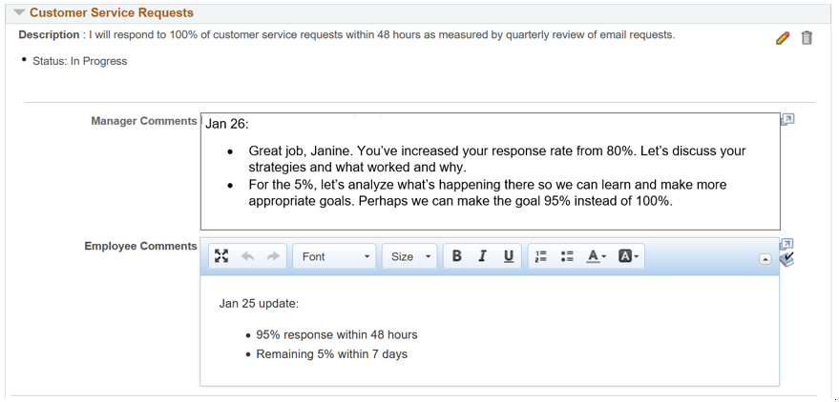

Competency Example
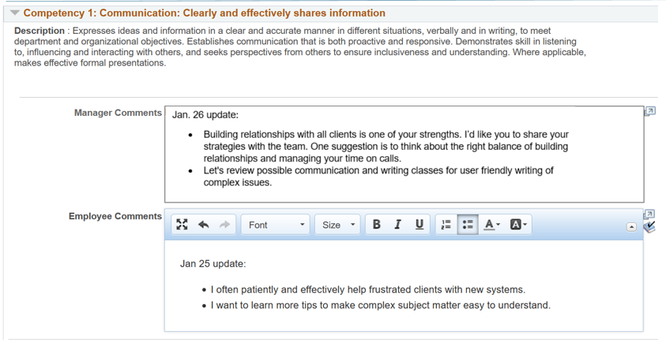

Example Question 2
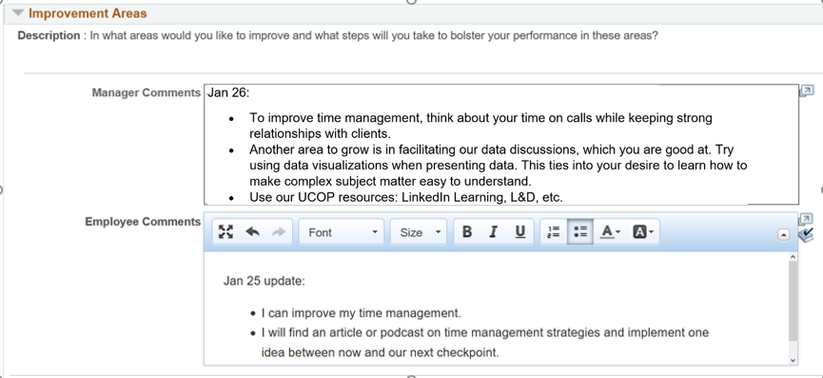

Bank of Questions/Statements for Reference

General Reflection:
- What strategies are working and why?
- What is a current challenge in your work? Why?
- What new practice/ work areas came easy for you? Why?
- What new areas were more difficult to change or develop? Why?
- Did you have any “Aha’s” or learnings? What will you continue? What might you do differently?

Reflecting on Success:
- What do you see as your strengths?
- What is the work you are most proud of?
- What do you do to be successful in this goal/ competency?
- How can you use these same actions/practices/strategies elsewhere?
- How do you keep focused on your goals when work is busy?

Reflecting on Area of Growth:
- What do you see as an area of growth? Why?
- What makes this area challenging for you? Why?
- What gets in the way of your progress in this area? How can we remove this barrier?
- Think of a success….What can you use from an area of success to help you in this area of growth?
- (After giving feedback or suggestions) What resonates about the feedback/suggestion? What do you agree with?

Statements/ Questions for Resistance:
- I am telling you this because… (I believe that you can improve, I want you to be successful, OR you are a valued member of the team). Let’s think together about concrete ways to improve.
- I understand this is difficult to hear. My intention is to help you succeed. I want to be clear about what is expected so that I can help you work on these skillsets.
- I am sharing what I have observed. Do you have additional work or examples to share so I can better understand your point of view?
- Let’s look at our department and team goals. What I am really looking for is to support you so your work is impactful. Our team goal is [goal], and we really need your work to help us with these goals.

Determining Action Steps
- What next steps are needed?
- What do you need to do first to start on this work?
- What support do you need with these action steps?
- Let’s calendar the next time we will check in on this action step.

Determining Support
- What support do you need with your next steps?
- What can I or other teammates do to support you?
- What supports you to keep focused on your goals during busy times?
- What skills would you like to develop?
- What are your professional goals for the future? Are there areas you would like to learn or grow in? (attend classes or receive stretch assignments while in current role)

What to do when emotions run high:
- I need to get my thoughts better together to have a more fruitful discussion. Can we continue this discussion at a different time?
- Thank you for your feedback. I’d really like to give this some time to be able to be thoughtful in my response. Can we continue this conversation at a different time?
- I noticed your tone has shifted. Would it be helpful to take a break?
- I can sense that you might be feeling a little frustrated by this conversation… Let’s end for now and pick it up at our next one on one.

