STEP Checkpoint Guidance
Topic | Possible Desired Outcomes | Questions to Ask Yourself | Tips
Goals | - Communicate my accomplishments and any obstacles | - What are some examples to show my efforts and inform our conversation? | - Update this often between Checkpoints so you don’t have to try to remember everything
Competencies | - Communicate my progress with my chosen competencies | - How has my work with this competency added value to my team or department?  - What feedback have I received from others that I need to consider?  - What have I accomplished? What have I learned? | - Review the UC Core Competency ABCs document  - Update this often in between Checkpoints so you don’t have to try to remember everything
Question 1:  Fulfilling Accomplishments | - Celebrate my wins!  - Communicate to my manager my interests and what motivates me | - What do I really want my manager to know about my interests or motivations?  - What work did I do that I particularly enjoyed? | - This can be about your goals or any other accomplishments  - You can broaden your thinking and add accomplishments towards organizational, department, and team goals
Question 2:  Improvement Areas | - Identify at least 1-2 areas with specific action steps to take  - Communicate my progress on previous improvement areas | - What is the one thing that I could improve on that would have the greatest impact?  - What feedback have I received from others that I need to consider? | - If emotions run high, it’s okay to ask to take a break  - Have a growth mindset. Remember we all have areas to improve in.
Question 3:  Resources Needed | - Communicate to my manager how they can support me  - Be honest with my needs | - What could help you accomplish your goals or get your work done?  - What obstacles are in my way? What are some possible solutions? | - You don’t have all the answers, it may be enough to just start the conversation with your manager  - Be solution oriented  - Be honest with what you need. You never know if you don’t ask!
Question 4:  Manager Accountability | - Identify an action for my manager to start, stop, or continue  - A more honest relationship with my manager | - What is the one thing that if my manager addressed would have the greatest impact?  - What’s my manager doing that is really supporting me well? | - Show care when providing feedback  - Have a growth mindset. Remember we all have areas to improve in.  - It’s okay to take a break if needed

Examples

Example Goal Update
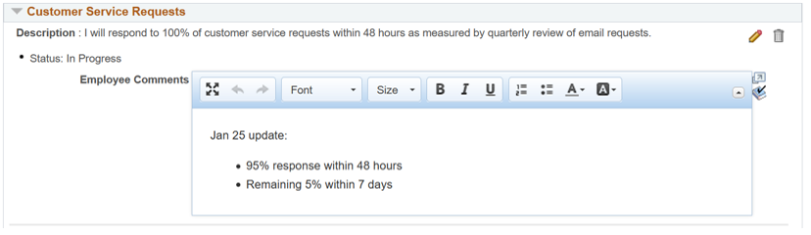

Example Competency Update
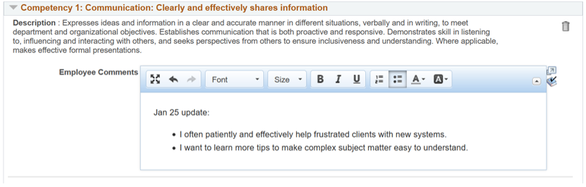

Example Q1 Response
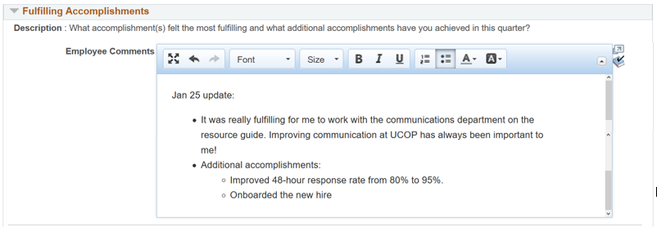

Example Q2 Response
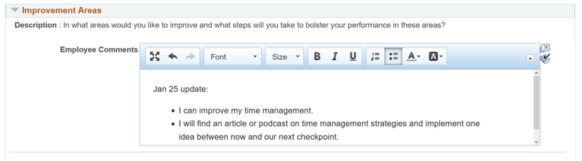

Example Q3 Response
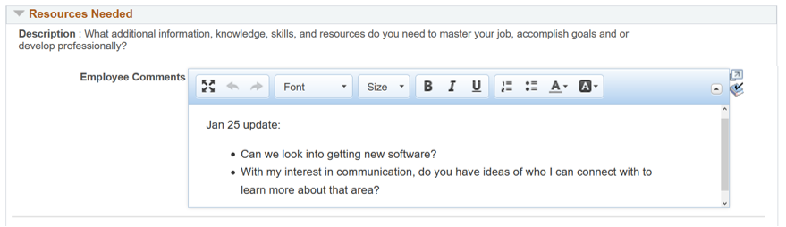

Example Q4 Response
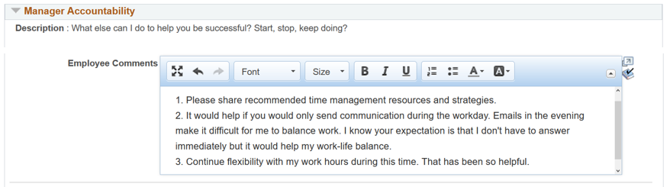

Examples: Sentence Starters
Get the conversation going.

Giving Feedback
- Start with Positive Feedback
  - “It is helpful to me when you [describe action] because…”
  - “Something I really appreciate about you is…”
- Introducing an Area of Need
  - Start with your ideal outcomes. “I really want to be highly responsive. One thing that makes it hard [describe what makes it hard].”
  - Start with a team goal. “Our team goal is ______. I want to meet this goal, and one thing that would help me is [describe what you need to be changed].”
  - Contrast: “I don’t want you to think _____. I just want to talk about the expectations around emails at night.”
- Situation-Behavior-Impact (SBI). Describe a specific Situation, the Behavior, and the Impact it had on you.
  - “Last Wednesday night you sent me an email at 11pm requesting the project data. It seemed like you were working at that time and wanted it immediately. That made me feel like I had to choose between my work-life balance and being responsive to you and the team.”
- Offer a Solution
  - “What do you think about [describe solution idea]…”
  - “Can I offer an idea?”
- Ask a Reflective Question
  - “What are your thoughts?”

Receiving Feedback
- Start by thanking your manager for sharing the feedback
  - “Thank you for sharing your observations on ______.”
  - “I appreciate you sharing this feedback with me.”
- Ask questions for clarity or ask for support
  - “You mentioned improvement on [behavior]. Can you show me some examples?”
  - “Can you share strategies that have worked for you or others?”
  - “I want to be sure I understand. Can you clarify with some further examples of this behavior?”
- Ask for time to process
  - “Can I sit with this information before I respond?”
  - “Thank you for sharing. I want to make sure I respond thoughtfully. Can we reconvene later or tomorrow?”
  - “I need some time to process this information. Can we resume this discussion tomorrow?”
- Acknowledge follow-up or next steps
  - “Thank you for that feedback. I will be sure to [describe action].”
  - “That information is helpful. Next time this occurs, I will [describe action.”

Always remember to thank your manager for listening to or giving feedback
- “Thank you for listening to my feedback/suggestion and for working with me on a solution.”
- “Thank you for your feedback. It gives an opportunity to grow.

