Completing the
Performance Appraisal 19/20

Workbook
Employee Training

Table of Contents
Using this Workbook and The 2019 – 2020 Appraisal Process and Timeline 3
Completing a Self-Appraisal in Halogen 4
Halogen Guide: Finalizing Goals for your Self-Appraisal 4
The Steps of the Performance Appraisal Process 5
Ratings Definitions and Behaviors 6
Behaviors Associated with Ratings 6
Group Exercise: Rating of SMART Goals 8
Additional example of: Rating of SMART Goals 9
Core Competencies and Behaviors 10
Overall Ratings 12
Performance Appraisal Feedback 13

Using this Workbook and Today’s Session

This workbook is meant to accompany the Completing the Performance Appraisal Training workshop.
Use this workbook to take notes, complete in session activities, and use as a reference while performing similar tasks back on the job.

The 2019 – 2020 Appraisal Process and Timeline

Appraisal Period: April 1, 2019 - March 31, 2020
- Write Self-Appraisal: March 09 – March 30*
- Multirater: By April 3
- Manager/Supervisor Writes Appraisals: By May 1
- UCOP Multi-Level Ratings Review: May 1- June 2
- Appraisal Delivery and Sign-off: June 3 – 30

* Two due dates have been communicated for the self-appraisal, Friday, March 27 and Monday, March 30. Either date is acceptable.
Jun
May
Apr
Mar
Appraisal Delivery and Sign-off
Mgr./Sup. Appraisal
Writing
Self-Appraisal Writing
UCOP Ratings Review

Completing a Self-Appraisal in Halogen

Halogen Guide: Finalizing Goals for your Self-Appraisal
IMPORTANT: Goals must be fully edited in the Goals section in Halogen before you open the appraisal document.
When you open the appraisal document, your goals will be imported into the appraisal. After that occurs, you will not be able to further edit your goals.

Please refer to the How to Complete a Self-Appraisal (pdf) guide on the UCOP performance management Learning Resources page.

What’s new in Halogen in 2020?

Using user feedback, we have simplified the 2019-20 year end forms by reducing the redundancies.

Changes to Forms
Section | Same | Different
Goals | Rate and comment on each goal | No “overall goal rating” nor “overall goal comments
Competencies | Ratings on each competency  Overall competency comments | No comment boxes for each competency  No “Overall competency” rating  Comment box at the end to be used for ratings above and below “successfully meets”
Multi-rater | Optional Process | 3 questions (down from 5)  - What did the employee do well?  - What are opportunities for improvement?  - Anything you want to highlight?

The Steps of the Performance Appraisal Process
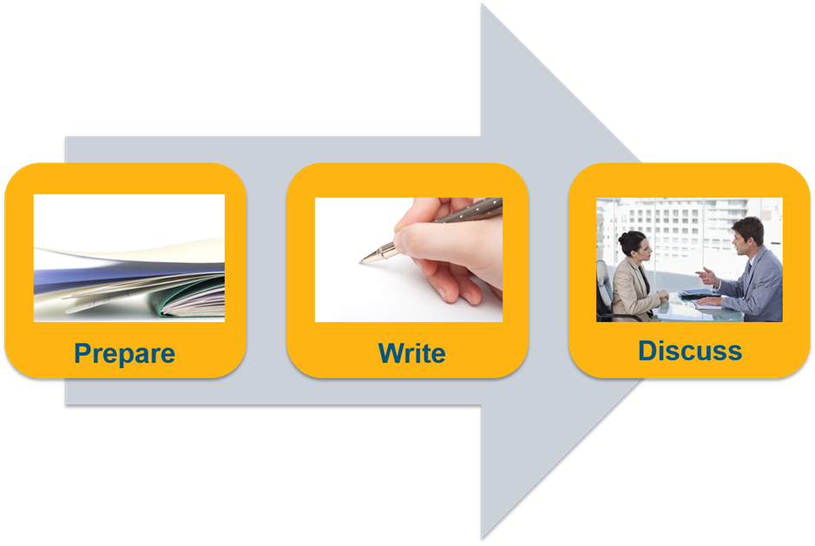

Prepare: Whether writing your own self-appraisal or an appraisal for another person, take time to gather supporting material of accomplishments and progress. You will want specifics to support the appraisal and the ratings.

Write: Use what you prepared to clearly illustrate each section of the appraisal. Use specific examples to clarify the merit of the rating. Be clear.

Discuss: After the employee self-appraisal and manager review are completed, discuss the results and revisit expectations for the next year and discuss new and in-progress goals.

Ratings Definitions and Behaviors

In your group, discuss the ratings definitions.
- Underline the defining words of each definitions.

Rating | Rating Definitions
Outstanding | Exceptional outcomes generated responding to unforeseen or changing circumstances; Consistently highest level of performance impact.
Exceeds Expectations | Very high level of contribution; Consistently performs above and beyond all defined expectations.
Successfully Meets Expectations | Strong, solid achievement of performance expectations, and at times possibly exceeding expectations. High level of contribution.
Development Needed/  New and Learning | Performance expectations partially met; moderate level of contribution; Some critical goals completed; achievement below expectations. Improvement needed in the position.  New in position, developing appropriately; performance was good given time in the position.
Does not meet expectations | Performed significantly below defined expectations; did not achieve organizational results. Immediate improvement action required.

Behaviors Associated with Ratings

 | Definitions | Examples of Behaviors Associated with Ratings
Outstanding | Exceptional outcomes generated responding to unforeseen or changing circumstances; Consistently highest level of performance impact. | - Role model among peers relative to this goal  - Exceptional outcomes generated responding to unforeseen or changing circumstances  - Effectively juggles multiple priorities and maintains a positive attitude even under high levels of pressure  - Contributions made to the overall department goals are clearly recognized by management and staff  - Consistently exceeds performance standards at the highest levels  - Adapts to changing situations and maintains a positive attitude
Exceeds Expectations | Very high level of contribution; Consistently performs above and beyond all defined expectations. | - Exceeds all agreed upon performance standards  - Readily and willingly assumes responsibility and accountability  - Will assume additional responsibilities when presented  - Clearly stands out among peers relative to this goal  - Recognized for expertise and leadership
Successfully meets expectations | Strong, solid achievement of performance expectations, and at times possibly exceeding expectations. High level of contribution. | - Consistently performs at the expected level for this goal  - Applies sound judgment when making decisions and makes infrequent errors  - Responds appropriately to questions and resolves problems  - Continuously works to improve performance  - Supports department colleagues and management in actions/communications
Development needed/  New and Learning | Performance expectations partially met; moderate level of contribution; Some critical goals completed; achievement below expectations. Improvement needed in the position.  New in position, developing appropriately; performance was good given time in the position. | - Inconsistent performance relative to expectation  - Requires considerable supervision and consultation to implement this goal in a timely, effective manner  - May fail to recognize and respond effectively to obstacles or changing priorities  - Demonstrates willingness to improve performance and accepts and applies constructive feedback  - Willingness to learn job responsibilities and improve  - Some critical goals met given time in new position  - With more time in position, will progress into a solid performer
Does not meet expectations | Performed significantly below defined expectations; did not achieve organizational results. Immediate improvement action required. | - Employee seems unwilling or unable to improve  - Regularly fails to successfully carry out responsibilities  - Requires substantial supervision and modification of this goal  - Unable to effectively respond to obstacles/crisis  - Often does not recognize issues or concerns and does not adapt to change

Group Exercise: Rating of SMART Goals
Consider the following SMART Goal:
By November 15, a written recommendation on best-practice communication approaches—based on an analysis of a minimum of 150 focus group interviews on manager/ employee communication patterns—will be delivered to the manager for sign-off.
- Review the SMART goal above and Read the outcomes for each rating below
- Start with “Successfully Meets Expectations” and then look at the others
- Discuss what differentiates each rating from the one next to it, and make notes in the right column
- Report out to the larger group
Rating | Comments | Reasons why this rating  might be chosen
Outstanding | A written recommendation includes detailed action and project plans which have a significant impact regarding how managers communicate with their staff members; serves as a model for UCOP regarding management practices; recommendations acted upon by senior leadership; additionally, analysis shows how the recommendations can reduce employee relations cases and provide potential cost savings; is delivered on time if not earlier than the deadline and is based on the analysis of a significantly larger number of UCOP employees and managers interviewed; Additionally, senior leaders were interviewed. The recommendation needs minimal, if any, edits.
Exceeds Expectations | A written recommendation, which is well written, goes well beyond the original by providing clear analysis that outlines a detailed action plan and guide for managers to increase staff engagement utilizing identified communication approaches and practices for staff at UCOP; additionally, provides a training outline and workbook for managers; is delivered on time based on more UCOP employees and managers interviewed than originally requested. The recommendation needs few, if any, edits.
Successfully Meets Expectations | A written recommendation is delivered on time and is based on the clear analysis of the agreed upon amount of UCOP employees and managers interviewed. Analysis of the data was very good and was consistent with the original request; actionable information was gleaned from the recommendation and it needs few, if any, edits.
Development Needed/  New and Learning | A written recommendation is delivered on time yet further revisions were required after the due date. Analysis was based on fewer interviews than requested and both employees and managers were interviewed. The recommendation can produce actionable results but will require a thorough edit to do so.
Does not meet expectations | A written recommendation is delivered after the due date and is based on the analysis of significantly fewer staff members interviewed; no managers interviewed. The recommendation needs a thorough edit with substantial rewriting and was not aligned to the original request and provides no actionable results

Another Example of SMART Goal Ratings at Different Rating Levels
Consider the following SMART Goal:
By the first Friday of every month, solicit updates and new material from our department's managers for the web page; publish this new material no later than the following Friday. Each time new material is published, review our department's web page for material that is out-of-date, and delete or archive that material.

Rating | Comments | Reasons why this rating  might be chosen
Outstanding | In addition to outcomes in exceeds expectations outcome, updated website layout to create faster access to the most requested customer concerns. Worked with IT to adapt web forms to be used for a UCOP wide implementation. Trained all department admins on web forms and web update process. After implementation, departments reported a 50% reduction in time spent on website updates | Exceptional unplanned contribution to create OP-wide impact creating faster access; highest level impact by not only training department administrative assistants but significantly reducing time spent on making updates.
Exceeds Expectations | Created a web form that department managers can directly input data and after review is uploaded directly to website. Created user guide. Simplified process allows for 2 updates per month leading to more updated accurate web data and increased web traffic by 40% in last 6 months. | Above level of defined expectations by not only meeting initial intent of goal, creating additional functionality of website and training users. Actions created larger impact as well.
Successfully Meets Expectations | Sends timely email and reminders to managers, stating due dates for new material. Publishes all new material by Second Friday. Clears all outdated material off website periodically during the month and archives material as needed on an on-going basis. Routinely seeks and receives customer feedback on the timeliness of information on the website. | Fulfilling original goal in a timely manner based on stated specifications Did what was asked and looks to improve the process based on feedback.
Development Needed/  New and Learning | Inconsistently sends emails to managers to remind them of deadlines for the website. Sporadically posts up new material, leading to inconsistently available material. At times does not remove out dated material from website, leading to phone calls from customers for clarification. | Partially meeting some aspects of the goal yet very inconsistently. Other aspects of goal not completed by failing to remove out dated material, leading to customer complaints.
Does not Meet expectations | Did not keep website up to date. | Is not achieving the level of consistency or the critical organizational aspects of this goal. Performance is significantly below expectations.

Core Competencies and Behaviors
Below are the UCOP core competencies and examples of demonstrated behaviors for each.

Collaboration and Communication  Builds partnerships and works collaboratively with others to meet shared objectives. | - Uses appropriate clear verbal and written communication that is timely  - Demonstrates balance between building and maintaining trusting relationships and getting work done  - Builds constructive and collaborative working relationships to achieve goals  - Willing to share information / knowledge with others
Customer/Client Service Focus  Dedicated to meeting the expectations and requirements of internal and external customers; gets first-hand customer information and uses it for improvements in products and services; acts with customers in mind; establishes and maintains effective relationships with customers and gains their trust and respect. | - Can describe customers’ organizational and expectations  - Demonstrates interest in customers’ needs and responds to needs in a timely fashion  - Seeks feedback to ensure customer needs have been met  - Proactively seeks ways to improve service delivery  - Goes beyond basic service expectations and solutions
Innovation, Creativity, and Change  Creates new and improved ways for the organization to be successful. Develops new and unique ideas; makes connections among previously unrelated ideas or concepts; tends to be seen as original and value-added in brainstorming settings. Supports change initiatives by defining measurable outcomes, energizing others at all levels, and ensuring continuing commitment when faced with new initiatives; confronts and works through concerns of various stakeholders. | - Experiments with new ideas, methodologies and solutions  - Thinks in terms of desired outcomes, not just quick solutions.  - Responds positively to change, embraces new opportunities and practices to accomplish goals or solve problems  - Adapts approach, goals and methods to achieve solutions and results appropriate for situation
Job Mastery  Demonstrates technical competence and job knowledge when completing job duties; possesses the skills and knowledge to successfully perform all parts of the job effectively and in a timely and efficient manner. | - Uses skills and knowledge and applies them to all aspects of position; willing to learn new skills and knowledge as needed  - Ensures that work and information are complete and accurate; follows up with others to ensure that agreements and commitments have been fulfilled  - Shows personal commitment and takes action to continuously improve

Principles of Community  Models and promotes equitable, fair, and inclusive behaviors. Fosters a positive working and learning environment by maintaining a climate of collaboration, fairness, cooperation, ethical behavior, and professionalism. | - Contributes to creating an environment of mutual respect and considers differences to encourage an open exchange of ideas  - Is able to see the merits of perspectives other than his/her own  - Is sensitive to and seeks to understand cultural norms, expectations  - Maintains professional and respectful work relationships
Problem Solving/Decision Making  Makes good decisions based upon a mixture of analysis, wisdom, experience, and judgment; most of his/her solutions and suggestions turn out to be correct and accurate when judged over time; sought out by others for advice and solutions. | - Uses sound judgment to make clear, transparent and timely decisions based on relevant information and data  - Recognizes issues, problems, or opportunities and proposes solutions  - Evaluates the pros and cons, risks and benefits of different solution options  - Seeks advice from their supervisor and request help from others when needed
Self-Management  Sets and manages priorities. Demonstrates execution of goals and objectives that support the overall success of the strategic objectives of the department. Completes work on schedule; produces work that has few if any errors; utilizes resources available to maximize efficiency. | - Pursues tasks with sense of purpose and a need to finish objectives despite obstacles and setbacks  - Recognizes critical tasks and is able to prioritize multiple competing tasks or goals  - Uses time effectively to accomplish assigned work and deliverables  - Takes advantage of available resources (individuals, processes, departments, and tools) to complete work efficiently
Stewardship - Financial/Resource Management  Interprets and applies understanding of key financial indicators and priorities to make better organizational decisions. Demonstrates accountability, discretion, and sound judgment utilizing University resources. | - Embraces and promotes ethical values and standard when managing and using resources  - Understands and uses key departmental budgetary priorities in decision making  - Uses individual and UCOP resources effectively and efficiently  - Controls costs and conserves resources  - Works to minimize institutional risk by acting as a responsible agent of the University, by demonstrating accountability, discretion, and sound judgment when managing all financial and operations resources

Overall Ratings

At the end of each section of the Performance Appraisal there are overall ratings.
- Overall rating for goals
- Overall rating for competencies
- Overall rating of performance based on the combined overall rating of goals and competencies.
Goal #1
Goal #2
Goal #3
Goal #4
Exceeds Expectations
Successfully Meets Expectations
Successfully Meets Expectations
Successfully Meets Expectations
Collaboration and Communication
Customer/Client Service Focus
Innovation, Creativity, Change
Job Mastery
Principles of Community
Problem Solving/Decision Making
Self-Management
Stewardship/Financial Management
Outstanding
Successfully Meets Expectations
Successfully Meets Expectations
Successfully Meets Expectations
Successfully Meets Expectations
Successfully Meets Expectations
Successfully Meets Expectations
Development Needed

Overall
Performance Rating
Successfully Meets Expectations

Performance Appraisal Feedback

- Appraisal Delivery and Sign-off: June 3 – 30

Feedback – Areas of Success
- Make sure and ask questions about the details of what you did so you can ensure that you do it again!
- Get the details about which aspects of your behavior or performance that had a positive impact.

Feedback – Areas of Growth
- Focus on listening rather than responding
- Ask questions for details and guidance
- Ask for support and professional learning opportunities

You’ll get the most from feedback if you attempt the following:
- Listen and learn in all feedback situations.
- Ask for more details, and make sure you understand those details.
- Paraphrase or repeating in different words to clarify understanding.
- Never leave a feedback without agreed upon course of action.
​
Moving Forward​
- Finalize the feedback and course of action
- Schedule a follow up session, especially if you are not prepared to respond in the moment

Note: Feedback can be re-visited later if you are not prepared to respond in the moment.

