**Submittal for the Larry L. Sautter Award**

**Project Title:**

Information Security Awareness Campaign

**Submitter(s):**

David RustingDirector, ITS  
UC San Francisco  
1855 Folsom Street   
San Francisco, CA 94143  
415-502-1593  
david.rusting@ucsf.edu

**Project Team:**

David Rusting, Project Sponsor

Patrick Phelan, Manager

Travis Carroll, Analyst

Vickarl Galvan, Analyst

Susan Yates, Creatvie

Hooman Moayyed, Coordinator

**Project Summary**

Information Security Awareness is key component of an overall security program. Historically, UCSF has done this through Powerpoint presentations for the IT community. While useful, it did not have the reach and engagement to address the critical threats facing the University. The UCSF Information Security Office decided to take “campaign” based approach, with targeted theme based on the leading threats to UCSF. The information was delivered through multiple channels and mediums, with the goal of increasing awareness and education, increasing adoption of security protections, and decreasing significant security incidents. The campaign was launched in April of 2012, and has met with great success, so much so that its approach and materials have been leveraged by other UCs as well as other “brand-peers” such as Harvard. Other awareness programs, such as Conflict of Interest, have sought to replicate this success. By all measures, this project exceeded expectations, and demonstrated that there are security awareness can be delivered in an engaging manner.

**Project Description**

The project started with the premises that “people are the new perimeter”, and that technological controls and can only go so far in protecting the security of data. People are, at the same time, the best defense and weakest link when it comes to information security. The goal was to drive breaches down, and drive adoption of protective technology, such as encryption and endpoint protection higher.

Among the core features of the campaign were:

* Multiple channels of communication – web, print, email, online training
* Continuous – Rotating monthly themes
* Giveaways and prizes – monthly themes based, and larger prizes

The campaign architecture followed this structure:

Marketing Process.wmf

A creative agency was engaged to help work through concepts and designs based on our leading threats of lost/stolen devices, compromised credentials, and compromised computers. Once the template was generated, the Information Security staff developed the specific photo and messaging for each monthly theme. These themes were turned into post-up stands, foam core poster, shuttle ads, and student newspaper (Synapse) ads.

These posters were strategic placed at over 30 locations across the multiple campus sites.

The posters can be viewed at this site: <http://it.ucsf.edu/services/outreach>, with the left column listing each of the themes.

In addition, a micro-site was created for the campaign, with short quizzes and videos. Small prizes given out to participants, and there were also large monthly prizes, including tablets and media players. We also tied incentives in the UCOP sponsored online security awareness training module; with $50 gift card drawings for those that completed the training. The site had linked to the main security site, which promoted free IT security services, and had links to other educational resources.

The site can be viewed here: <http://awareness.ucsf.edu/>

The videos can be seen at: <http://it.ucsf.edu/services/outreach/awareness-videos>

News articles were also placed in Pulse, the online UCSF news, as well as Synapse, the UCSF student newspaper. See: <http://www.ucsf.edu/news/2012/03/11603/ucsf-launch-new-data-security-campaign>

After taking the quizzes and watching the videos, the person’s email address was captured, and that person received emails each month about the new monthly theme.

**Technology and Materials Utilized**

The Security Awareness Program used:

* Web site platform: LAMP stack
* Post-up and foam core posters.
* Photos from UCSF Documents and Media, UC Davis, and Stock photography
* UCSF Education Technology Service video production services
* ePromos collateral/premiums

In many ways, this was “low-tech”. Print media, posters, emails. But it worked, because these ads were in high traffic areas, and they stood out. We also took the “show on the road”, promoting it as faculty and student events:

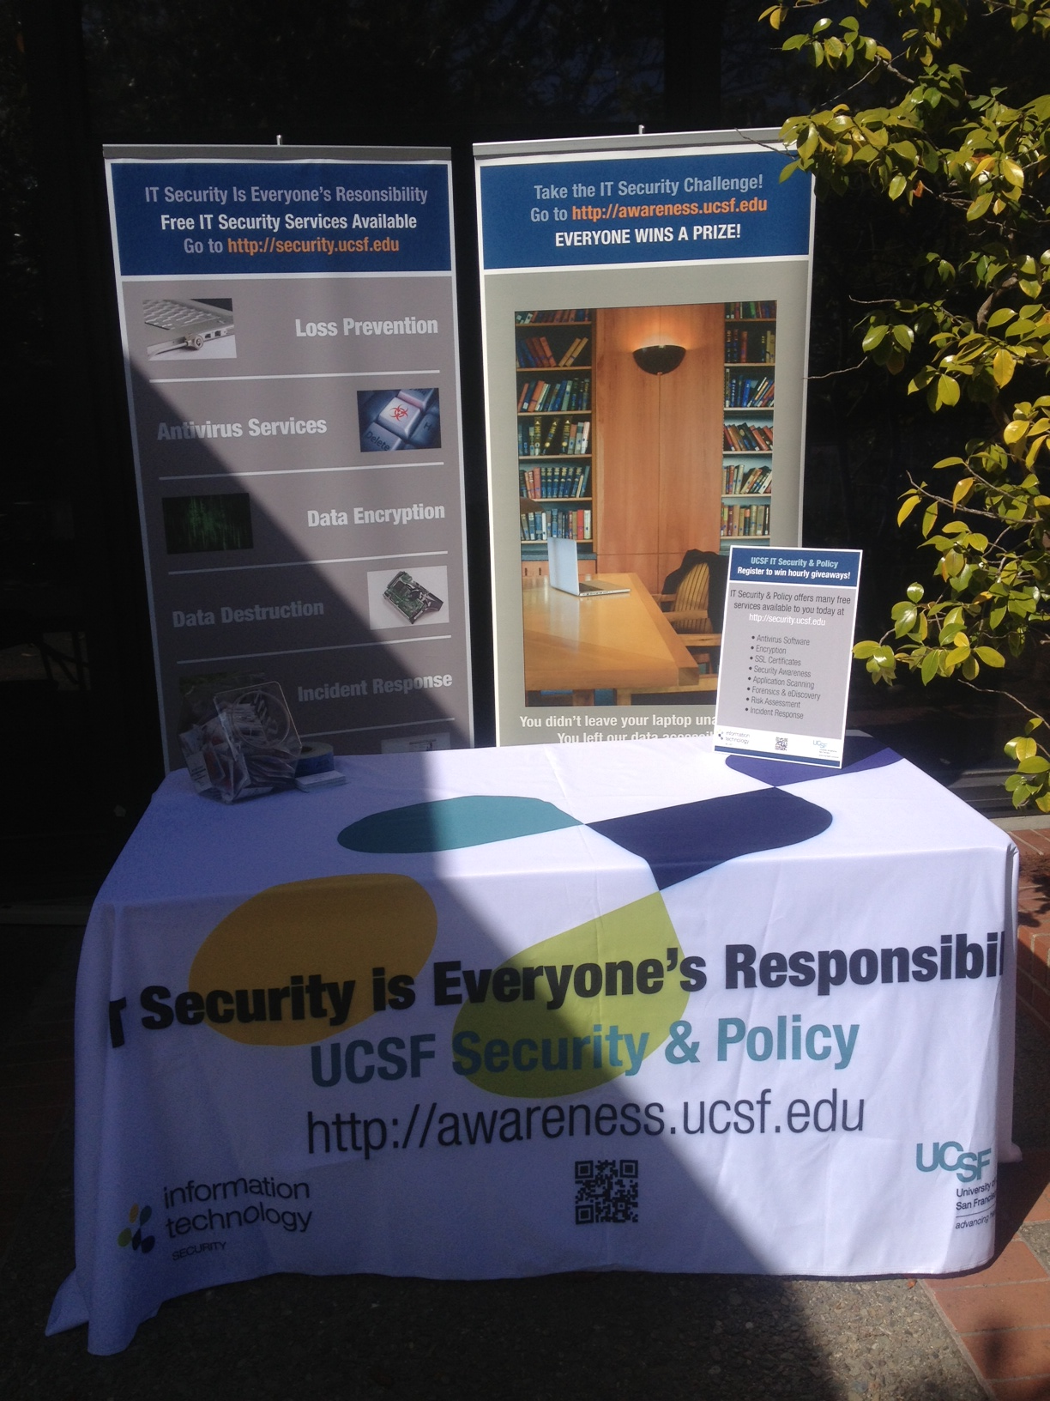

The giveaways were tied to the theme – hand santizer on anti-virus awareness month; travel chargers during travel safety month; free music download during copyright awareness month.

**Timeframe of Implementation**

Summer 2012 Creative work

Fall 2012 Site build and collateral development

March 2012 Beta site launched

April 2012 Soft launch

May 2012 Full release

June 2012-present Monthly theme rotation

**Customer Satisfaction Data / Metrics**

1. **Over 6,000 people have visited the site**. 500-800 per month, 40% return visit rate. That represents 25% of the overall campus population.
2. **Encryption and endpoint (anti-virus) adoption each rose 50% over the period of the campaign**. Influenced in part by the campaign.
3. **Other UCs leverages the content.** Word of mouth spread, and the template for the printed materials were shared with other UC campuses and medical centers.
4. **Recognized outside of UCSF**. The Association of American Medical Colleges selected this program to be presented at their annual conference on information technology In Vancouver. Also, Beth Israel Deacon Medical Center (Harvard affiliated), modeled their program after the UCSF program.
5. **Significant breaches dropped from 11% prior year to 3% during campaign year**. Influenced in part by the campaign.