UCSD Marketplace
(Online Procure-To-Pay Solution)
2011 University of California Larry L. Sautter Award
for Innovation in Information Technology

Table of Contents
Project Information 3
Project Name 3
Submitter Contact Information 3
Project Leaders, Stakeholders, and Team Members 3
Summary and Significance of Project 4
Project Description 4
Flexible Access for Employees and Affiliates 5
Guided Procurement via Catalogs and Custom Forms 6
Customized Business Unit Management of Roles and Approvals 8
Automatic Routing of Requisition, Purchase Order, and Invoice Documents 9
Electronic Transmission of Purchase Orders, Order Acknowledgements, Shipment Notifications, and Invoices 10
Visibility & Transparency 11
Detailed Spend Reporting 13
Implementation Success Metrics and Additional Benefits 13
Transactional and Operational Efficiencies: 13
Improvement through Innovative Solutions: 13
Collaboration and Integration across UCOP and UC Campuses: 14
Technology Used 14
Timeframe of Implementation and Rollout 14
Supporting Documents 15
Objective Customer Satisfaction Data 15

Project Information
The follow information is being submitted for consideration for the 2011 University of California Larry L. Sautter Award for Innovation in Information Technology.

Project Name
UC San Diego, Marketplace

Submitter Contact Information
Gisella Falossi  Senior Program Manager, Marketplace  Procurement & Contracts  Business & Financial Services  University of California San Diego  9500 Gilman Drive # 0914  La Jolla, CA 92093-0914  Phone: 858.822.2420  Email: gfalossi@ucsd.edu | Bill Sweetman  Manager Financial Link & Marketplace  IT Applications Group  Administrative Computing & Telecom  University of California San Diego  9500 Gilman Drive # 0929  La Jolla, CA 92093-0929  Phone: 858.534.6060  Email: wsweetman@ucsd.edu

Project Leaders, Stakeholders, and Team Members
LEADS:
- Gisella Falossi, Senior Program Manager, Procurement & Contracts, gfalossi@ucsd.edu
- Bill Sweetman, Manager Financial Link & Marketplace Applications, ACT, wsweetman@ucsd.edu
STAKEHOLDERS:
- Steve Relyea, Vice Chancellor External & Business Affairs, srelyea@ucsd.edu
- Ted Johnson, Chief Procurement Officer, Procurements & Contracts, edjohnson@ucsd.edu
- Faye McCullough, Director of Disbursements & Travel, Disbursements, mccullof@ucsd.edu
- Emily Deere, Director of IT Applications Group, ACT, edeere@ucsd.edu
TEAM MEMBERS:
- Jennifer Glassman, Content Enablement Specialist, Procurement & Contracts, jglassman@ucsd.edu
- Nikki Giaquinta, Site Administrator, Procurement & Contracts, ngiaquinta@ucsd.edu
- Ellen Sanders, Asst. Director, Disbursements, esanders@ucsd.edu
- Sue Maciel, eProcurement & Reconciliation Manager, Disbursements, smaciel@ucsd.edu
- Douglas Shieh, Marketplace Software Engineer, ACT, sshieh@ucsd.edu
- JianJun Li, Java Developer Marketplace, ACT, jijli@ucsd.edu
- Jingjing Wu, Programmer Analyst, ACT, jiw002@ucsd.edu

Summary and Significance of Project
In 2004, leadership at University of California, San Diego identified a need to transform the procurement of goods and services at the University from a transactional to a value-added strategic process. The catalyst behind this shift was the potential to generate significant cost savings by funneling purchases through a common set of contracts made available through a single electronic procurement portal. Leadership also desired to have an innovative and effective procurement process that was worthy of supporting our world class research enterprise. The timing of this initiative coincided nicely with the introduction of the University of California system-wide Strategic Sourcing program, which negotiated contracts based on the consolidated spend of all ten UC Campuses and five Medical Centers.

Previously at UC San Diego, the Procurement & Contracts department supported the buying of goods and services for the campus through multiple systems and processes. Campus users were directed to a specific system or process based on the commodity, supplier or purchase amount. A great deal of institutional knowledge was required to navigate the multiple systems each with varying levels of end-to-end transactional process costs ranging from approximately $10 (Express Order/Express Card) to over $125 (IFIS HVPO) per transaction. Available controls and associated reporting/data varied greatly between the systems and the role of the Professional Buyer was primarily transactional in nature, with value placed on how quickly transactions could be processed and issued to suppliers. As the campus continued to expand both in terms of people and the complexity of goods and services, it became apparent that the previous buying system(s) were no longer sustainable.

As such, executive leadership identified the need to consolidate the procurement of goods and service under a single platform, branded “Marketplace”, with the following vision in mind.

Create a tool that provides campus with:
- One stop shopping site for all buying and payment related activities
- Fully leverage the UC system-wide and UCSD Strategic Sourcing Program
- Intuitive and easy-to-use online shopping site
- Effective Control and Accountability

In order to execute this vision, the executive leadership and stakeholders established the Marketplace Project Team, charged with implementing the awarded SciQuest HigherMarkets eProcurement solution which included the following modules: Spend Director, Requisition Manager, Order Manager, Settlement Manager, Contract Manager, and Sourcing Manager. Additionally, in order to support the SciQuest application, the Marketplace Project Team developed two (2) supporting applications and processes: the Business Unit Management Tool and the Marketplace Maintenance Tool.

Project Description
During the requirements gathering period, it became apparent that in addition to translating the current business processes into a new eProcurement environment this implementation would also serve as an ideal opportunity to adjust the campus perspective of the entire procure-to-pay process.

The balance between developing a streamlined purchasing application, while still preserving the functionality that allows for the unique needs of the 250+ Departments that make up UC San Diego, was and still is the most significant challenge that the Project Team faces. The areas listed below outline where the Project Team was instrumental in maintaining maximum flexibility for a diverse campus, instituting process efficiencies for our internal and external partners, and improving financial control and accountability measures, while still maintaining the goal of an intuitive and easy to use single shopping portal.

Flexible Access for Employees and Affiliates
Objective: Grant access to all employees and affiliates that need to source, shop, request, and/or approve purchases for goods and services on behalf of UC San Diego.
Solution:
- For the ~23,000 UC San Diego employees, we automatically granted all users access to the application via a default “Window Shopper” role.
- Utilizing the existing Single-Sign-On (SSO) shibboleth process, the end user is authenticated, contact information is collected, and then combined with any additional designated shopper or approver roles. The sign-on process then creates a Login.xml file that formats all required information for the SciQuest user profile and logs the user into the Marketplace application.
- UC San Diego research projects are often collaborative with other outside organizations (i.e. Ludwig Institute, The Scripps Research Institute, NOAA, and HHMI), so it was necessary to develop and support functionality to allow non-UCSD Employees access to the Marketplace application. This was done by utilizing the existing UCSD MyAffiliates program to allow departments to first sponsor non-UCSD employees, and then grant them higher level shopping roles and/or approving roles in Marketplace. The sponsored affiliate is then marked with an attribute that identifies them as an affiliate. (screenshot below)
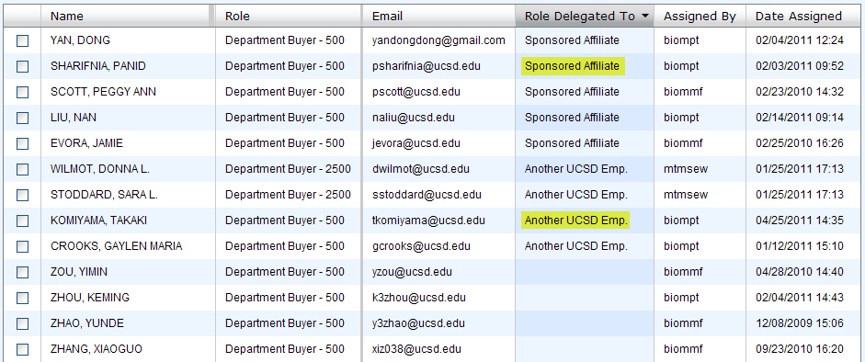
- There are also times when collaborative research projects within UC San Diego cross multiple departments. We consider this type of access or roles assignment a “cross-delegated” role. For example, the Biology Department, can grant an employee in Chemistry a Biology shopping or approving role, which allows the Chemistry user to buy against Biology funding using their delegated role. This person and corresponding role is then identified with a “cross-delegated” attribute. (screenshot above)
- Since the “cross-delegated” feature exists, it is possible that a user on campus can be granted shopping roles in multiple departments. If the SSO process identifies that a user has multiple shopping designations, are prompted during the login to select the department they are shopping on behalf of. This selection then drives the Login.xml logic to link to the correct profile to the correct role assignment. (screenshot below)
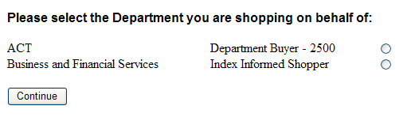

Guided Procurement via Catalogs and Custom Forms
Objective: Guide users to the appropriate product or service from a contracted supplier, fully leveraging the UC and UCSD Strategic Sourcing Program, and provide proactive direction on existing purchasing policies, federal funds requirements, and additional documentation that will be needed to efficiently process high dollar or complex purchases.

Solution:
- Products and services that have been awarded to a contracted supplier through the strategic sourcing process are prioritized and flagged in the search results. (screenshot below)
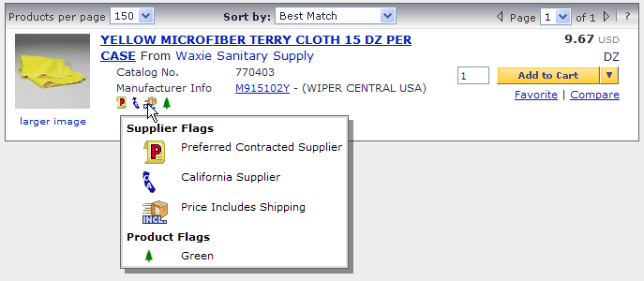
- For complex purchases that require configuration or for supplier specific quotes, some contracted suppliers were enabled via punchout catalog with quote retrieval functionality. (screenshot below)
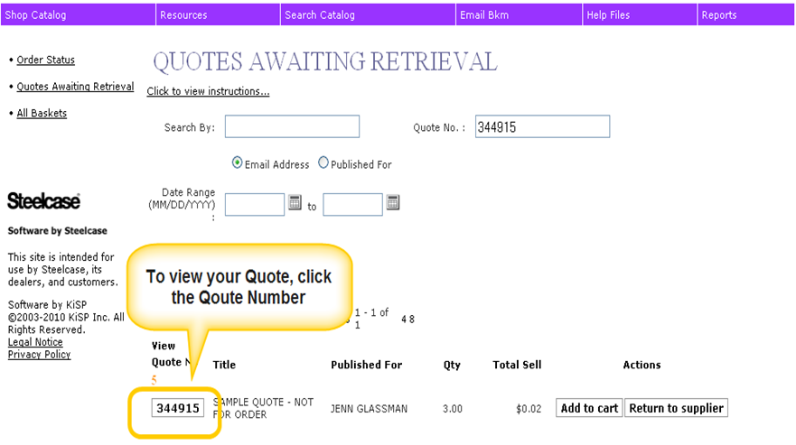
- For complex purchases that require additional information be provided by the end user due to purchasing policy, federal funds requirements, or specialty or restricted items, forms were custom created to guide the user using leading questions and required fields through the purchasing process. Sample Form iRequest.png
- Custom Form Type: | - Custom Form Use:
One-time Purchase of Quoted Goods or Services | When you have quoted pricing or promotional code for products and/or services
Independent Contractor Services | When you are requesting Independent Contractor Services
Recurring Services | When you are certain services will occur  When you need to purchase on an ongoing basis
Equipment Maintenance Service Agreement | When you are certain services will occur  When you have received a quote/estimate for repair services, you have a piece of UCSD equipment that requires regular service/maintenance over a specified period, typically 1 year
Scheduled Delivery Supplies | When you plan to have partial quantity shipments and you have a pre-defined list of items you are ordering

- Utilization of Ordering Instructions for products and services that are not conducive to, or not allowed through, the traditional eProcurement process. (screenshot below)
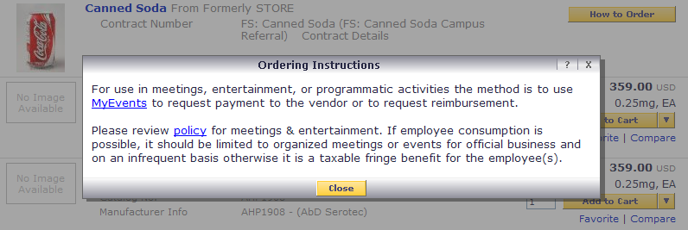

Customized Business Unit Management of Roles and Approvals
Objective: Establish a flexible approval framework which grants each department the ability to delegate designated shopping roles and define the internal approval routing requirements that best support their unique business needs, while maintaining campus-wide consistency in financial approval requirements.

Solution:
The Business Unit Management Tool supporting application was developed with two main purposes.

- Allow departments the ability to designate employees and sponsored affiliates pre-defined shopper roles, as appropriate with their internal business process. (outlined in the table below)
- Shopper Role: | - Delegation Level:
Window Shopper | Default role, if no other role is assigned. Shopper can only create carts and assign carts to another user.
Index Informed Shopper | Shopper can create and submit carts for approval.
Department Buyer - 500 | Shopper can create and submit carts for approval. Requisitions <$500 are automatically processed without requiring additional approval based on the delegation level granted with this role.
Department Buyer - 2500 | Shopper can create and submit carts for approval. Requisitions <$2,500 are automatically processed without requiring additional approval based on the delegation level granted with this role.
Department Buyer - 5000 | Shopper can create and submit carts for approval. Requisitions <$5,000 are automatically processed without requiring additional approval based on the delegation level granted with this role.

- Allow departments the ability to establish and configure Business Units, which identify the financial information that should be made available in Marketplace with those users authorized to approve against that financial accounting. (screenshot below)
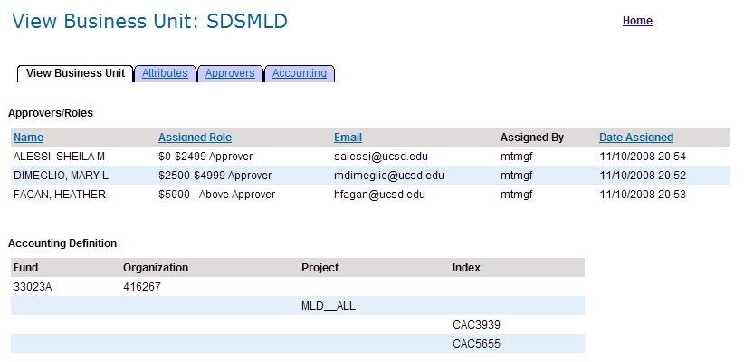

Automatic Routing of Requisition, Purchase Order, and Invoice Documents
Objective: Automatic and dynamic routing of Requisition, Purchase Order, and Invoice documents through an electronic workflow approval process which maintains key controls and improves audit compliance. Workflow routing includes but is not limited to: Financial approval, Departmental approval, restricted item and specialty product approval, Procurement & Contracts approval, and Disbursements approval.
Solution:
- A nightly synchronization occurs between the Business Unit Management Tool (BU MT) and the Marketplace application for the purposes of synching all Business Units, Business Unit approvers, and associated financial accounting information. Using a pre-defined customfieldfile.xml, the BU MT application runs a business unit integration program which pulls any new, modified, or inactivated data since the last synchronization. This nightly customfieldfile.xml then posts to SciQuest and updates all custom field data stored in the application which is used to route and drive workflow.
- Requisitions Workflow automatically validates and routes the requisition document based on financial, product, and supplier information to the appropriate approvers.
Requisition Workflow Diagram PR Workflow.pdf
- Purchase Order Workflow automatically creates and transmits an electronic version of the Purchase Order to the supplier and to UC San Diego’s ERP system (IFIS) after routing for any required post-requisition approvals.
Purchase Order Workflow Diagram PO Workflow.pdf
- Invoice Workflow automatically validates and routes the Invoice document based on matching definitions, tolerance thresholds, and dollar amount to the appropriate approvers.
Invoice Workflow Diagram Invoice Workflow.pdf

Electronic Transmission of Purchase Orders, Order Acknowledgements, Shipment Notifications, and Invoices
Objective: Utilize electronic integrations with internal and external Suppliers to maximize order processing efficiencies.
Solution:
- Enabled electronic cXML integrations with 28 contracted suppliers to quickly and efficiently transmit Purchase Orders and receive Invoices between Marketplace and the Supplier’s internal ordering processing system, expediting order processing and minimizing chances for manual data entry errors.
- Activated electronic Order Acknowledgment Notification and Advanced Shipment Notification integrations with the Marketplace website for key high-volume suppliers in order to reflect order status information directly within the site. (screenshot below)
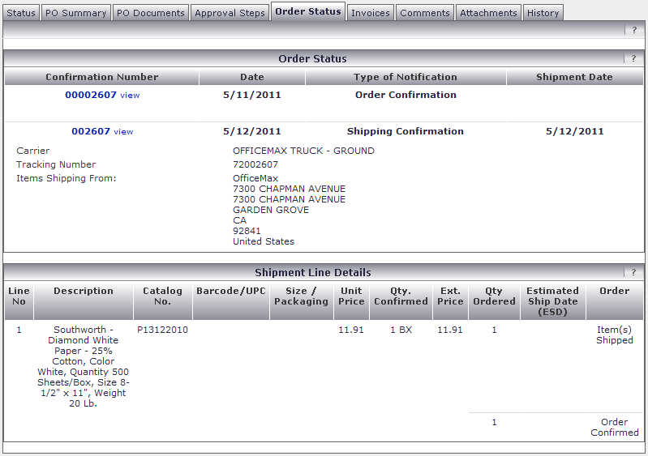

Visibility & Transparency
Objective: Provide real time visibility into all aspects of the procure-to-pay process.
Solution:
- The Marketplace application displays a diagram of the workflow process, which provides the end user with real time visibility into the status of any document, highlighting the current status, indicating future steps, and those authorized to approve in those steps. This visibility allows end users to easily track status, as well as contact the appropriate person in the event that a request for purchase or payment needs to be expedited. (screenshot below)
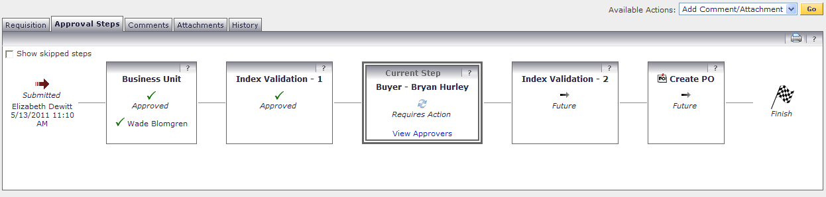
- A log of header and line level edits captures any change to a Requisition, Purchase Order, or Invoice document on the History tab. (screenshot below)
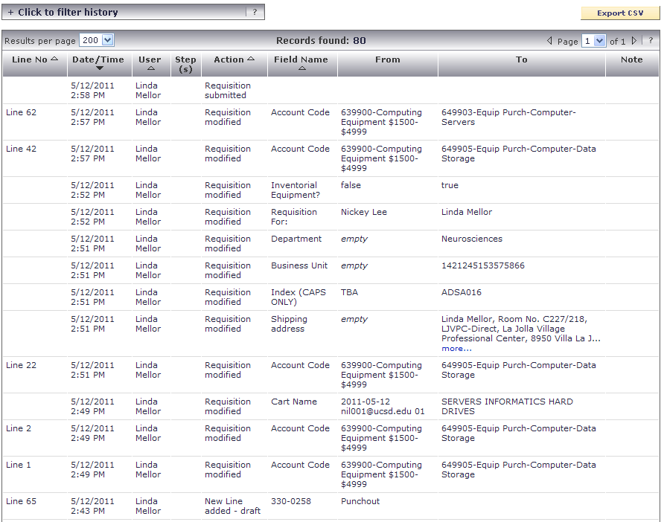
- The Marketplace Maintenance Tool supporting application was developed to audit the PO and Invoice load process between the export from SciQuest and the successful load to UC San Diego’s ERP system IFIS. If a document fails to load due to a data error or server error, the audit tool logs the document and sends an error message email to system administrators responsible for resolving. (screenshots below)
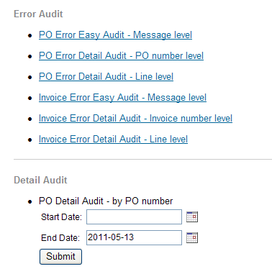
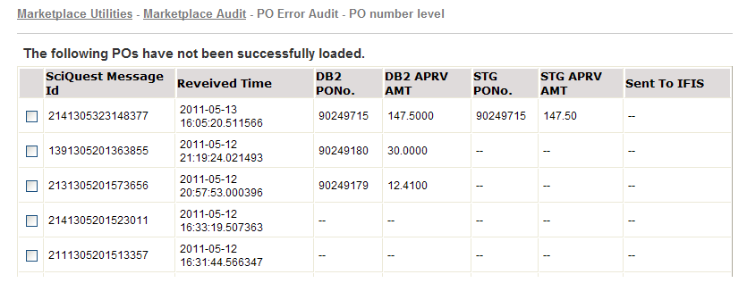

Detailed Spend Reporting
Objective: Capture line level detail of purchases and payments made within Marketplace, improving the quality of spend data available to UCSD and the UC system-wide Strategic Sourcing program used negotiating and executing future agreements.
Solution:
- Marketplace has an inclusive and dynamic reporting module that allows for detailed line level data of the products and services ordered and invoiced through the application. These reports can be filtered by supplier or commodity, saved and reused, and exported in .csv format for further manipulation. Sample PO Report – Raw Data Sample POData_PO April.csv
Sample PO Report – SciQuest provided PO Template PO_Data_Template_April_Sample.xlsx
- UC San Diego spend data is also made available at the UC Office of the President Consortium level for the five UC Campuses active on SciQuest.
- Since all Purchase Orders and Invoices are exported from Marketplace and loaded into UC San Diego’s ERP (IFIS), the Marketplace line level data is also made available in the Data Warehouse where it can be queried against to create a consolidated spend report inclusive of all other payment methods on campus.

Implementation Success Metrics and Additional Benefits
Since the Marketplace application was officially launched to the entire campus in January 2010, UC San Diego has seen numerous gains as a result of its transformation of eProcurement, some of which include:

Transactional and Operational Efficiencies:
- $2.2 Million in direct cost savings to the University from the implementation and use of Marketplace.
- Over $4.8 Million in in-Direct cost savings to the University from the implementation and use of Marketplace.
- Substantially enhanced control and visibility in procurement processes, as compared to the previous multiple legacy purchasing processes.
- Marketplace currently captures an average of 60% of all campus procurement transactions, with 100% of all Marketplace Purchase Orders automatically transmitting electronically to the supplier.
- Approximately 75% of all accompanying invoices are settled via an electronic Invoice document, no manual data entry and minimal review required.
- Cycle time for purchases has decreased from days to minutes, with 94% of all purchase order transactions finalized within one business day, 85% within 4-6 hours.
- Within a year of campus-wide deployment, an average of 7,500 unique users accessed Marketplace to browse, view contracted products and services, and submit carts.
- Of those granted authorization, 2,100 unique users have submitted or approved requisitions through Marketplace, accounting for over $93 Million in spend to date.

Improvement through Innovative Solutions:
- Campus User Experience: The single shopping portal has made it easy for campus users to buy on-contract in a familiar online shopping environment like those offered by popular e-commerce sites. By using custom forms and guided procurement, the end users have gained significant visibility on processing requirements, improving processing times by cutting the time professional buyers spend gathering required documentation.
- Transformation of the Professional Buyer Role: The role of the Professional Buyer has transitioned from transactional to strategic. Buyers, now called Procurement Relationship Managers, can focus their time on better understanding the needs of the campus and thus enabling both suppliers and operational efficiencies to better support the procurement process.

Collaboration and Integration across UCOP and UC Campuses:
- While the Marketplace implementation in itself is a significant accomplishment, the UC San Diego Project Team took things a step further by envisioning a common portal that could be accessed by all UC schools utilizing SciQuest as their eProcurement tool. This direction was aligned with the UCOP mandate aimed at eliminating administrative redundancies between the campuses.
- A joint effort with SciQuest, the UC Office of the President, and four other UC Campuses eventually resulted in the UC Consortium, which allowed UC system-wide contracts to be managed by a single point of contact at the UC Office of the President, thus eliminating redundancies at the campuses and at the supplier level. It also provided real-time spend visibility to the UC Office of the President for five campuses within the consortium.

Technology Used
The following lists the technologies used for this project and the benefits of using those technologies.
Application Area | Technology | Benefits
Marketplace Maintenance Tool, Business Unit Management Tool | Java, JLink, Yahoo UI, jQuery | JLink – provides standard & secure interface for app development  Yahoo UI - provides ready-to-use rich interface widgets  jQuery - easy and fast Document Object Model manipulations
PR Validation, PO & Invoice Processing | Java, JLink | JLink – provides standard / open interface via SOAP / REST services
Single Sign On | Java, Shibboleth, Yahoo UI | Shibboleth – Campus wide application authentication & authorization integration
Interface to legacy mainframe (IFIS) | CICS Web Services (z/OS) | Robust Web Services Platform; Using CICS Web Services enabled developers to re-use legacy COBOL PPS code currently used by screen-based CICS programs
Data Layer  (all applications & web services) | jLink DAO | jLink DAO - standard interface for accessing data across platforms.
Custom Field File | Java, JLink | JLink – provides standard & secure interface for application & web service development

Timeframe of Implementation and Rollout

Task | Timeframe | Notes
Project Kick-Off | March 2007 | Stakeholders, Sponsors, and Project Team identified.
Requirements & Business Decisions | 14 months | Project Team established 16 Subject Matter Expert (SME) Teams to collect and define various business decisions surrounding process change and key controls.
Technical Design & Development | 8 months | Analysis and design of data and document workflow, data elements, internal and external interfaces, database and service design, usage and server load.
QA & User Acceptance Testing | 2 months | SciQuest UAT Testing conducted in March 2008  End-To-End Testing conducted in April 2008
Pilot Launch | May 2008 | Released to 7 key Departments on campus, which participated in the requirements gathering process and the Business Unit development strategy planning sessions.
Pilot Rollout & Adjustments | 18 Months | Incrementally released to an additional 52 departments on campus; while simultaneously adjusting workflow configuration, ERP integrations, and user interface changes based on Pilot User feedback.
Campus-Wide Launch | Jan 2010 | Campus-wide release required the project team to market the new purchasing protocol and procedures to a sizable campus community comprised of more than 23,000 faculty and staff members shopping and/or buying authority.
UC Consortium Go-Live | April 2010 | Enablement of 13+ UCOP strategically sourced agreements and consolidated reporting across 5 SciQuest campuses.

Supporting Documents
The following attached documents include supporting details of the various areas addressed within this submission.
Name | Description
iRequest.png | Sample of custom form used in guided procurement
PR Workflow.pdf | Requisition Workflow Diagram/Outline
PO Workflow.pdf | Purchase Order Workflow Diagram/Outline
Invoice Workflow.pdf | Invoice Workflow Diagram/Outline
POData_PO April.csv | Sample PO Report – Raw Data
PO_Data_Template_April_Sample.xlsx | Sample PO Report – Placed in SciQuest provided PO Template
Marketplace Process Flow Audit Points.pdf | Document & data flow with audit controls

Objective Customer Satisfaction Data
I have worked at UCSD for 25 years, and have a great appreciation for the new Marketplace, as this system is so much better than the old mode of purchasing, and I would also like to say that I have always found the Marketplace staff very responsive to the input and the needs of its users.
-Sr. Editor, Chemistry & Biochemistry

Thanks to Marketplace…good motivation to go paperless…keeping up with technology is always great!
-Anonymous, Faculty and Staff Customer Satisfaction Survey2010
I enjoyed participating in the webinar. It was a very convenient and useful way to rollout marketplace. The amazon.com reference and explanation of cost savings potential to UC as a while was very meaningful and will help me “sell” this system to my department.
I also appreciate the follow up and opportunity to ask questions as they pertain to my specific department. Thank you.
-Executive Assistant, Dean of Social Sciences
Marketplace is a tool that I have been hoping would arrive one day, and lucky me, it is here!! Thank you, Thank you, Thank you!!
-Anonymous, Faculty and Staff Customer Satisfaction Survey2010
This has been an unbelievably wonderful transition in the depth and breadth of on-campus product purchasing knowledge. The staff in their entirety is probably the most professional department on campus, bar none.
-Anonymous, Faculty and Staff Customer Satisfaction Survey2010

Marketplace is a very impressive accomplishment, and is a huge savings to the campus at a time when it needs it the most. The savings generated from this program will eventually translate into better support for research and better access to higher education for our students.
I am proud of the UC San Diego team for the role they played in pursuing this kind of forward-thinking solution, which has had a positive impact throughout the UC System. It is a true example of innovation and multi-campus collaboration that has resulted in tangible efficiency gains throughout the UC System, while helping us to achieve our administrative cost-saving targets for the University of California.
-Vice Chancellor, Business and External Affairs
It’s a real convenient feature that the New Marketplace can change index numbers and mailing addresses per line item. It would have been much more difficult to do this type of large order using the Financial Link PO or express card systems.
-Lab Manager, Chemistry
I am very happy with the new marketplace. Lots of phone help when needed. Ordering is easy. Great improvement—huge time savings over generating POs in IFIS!
-Anonymous, Faculty and Staff Customer Satisfaction Survey2010

