Application for 2009 Larry L. Sautter Award for Innovation in Information Technology
University of California, Riverside – R’Space Portal for Faculty and Staff

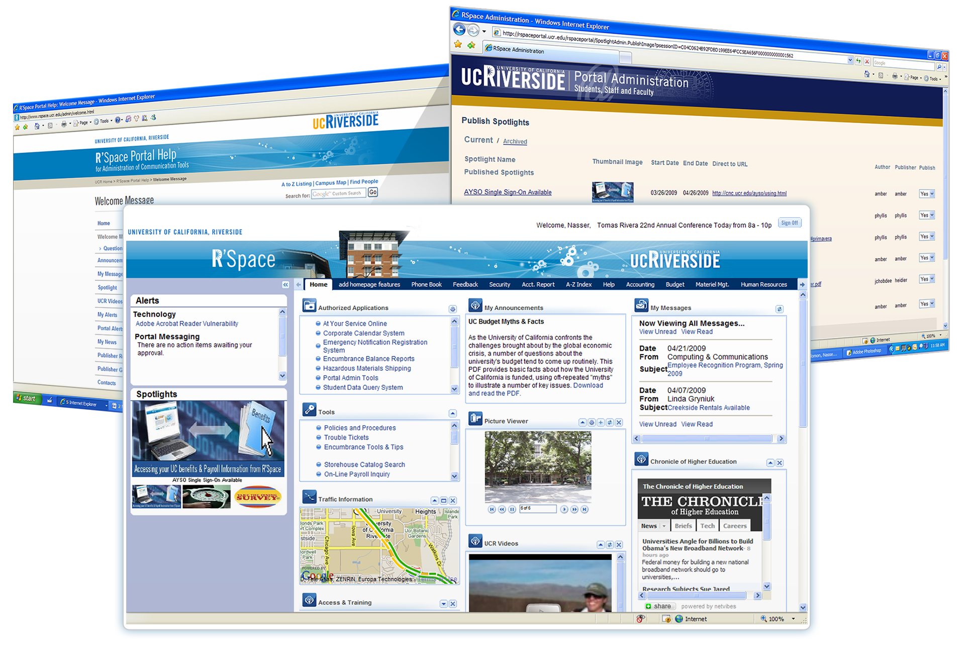
Overview
UCR released its first-generation transaction-processing portal (iViews) in 2005. While iViews was a convenient tool for accessing one’s authorized applications in a single sign-on environment, it had limited capabilities for communicating with end users and for enabling personalization of one’s workspace. As Computing and Communications (C&C) considered how it might best upgrade this tool, it faced the following realities:

- No incremental funding would be made available for this effort (no funding for license fees, staff, etc.). C&C has .75 FTE allocated to portal support.
- C&C does not have sufficient JAVA expertise to support a robust uPortal deployment (at least not with the flexibility it desired within the new portal).
- UCR has an incredible number of applications / data available to repurpose into an enhanced portal tool.

Given these challenges, C&C developed R’Space with no incremental funding using the Javascript EXT Open Source libraries. The success of R’Space provides the University of California with a third option relating to portal development. Campuses need not purchase vendor supplied solutions or adopt the uPortal framework; rather, the Javascript EXT Open Source libraries can be used to support a dynamic, engaging, state-of-the-art presentation tool leveraging existing campus applications and databases, open source functionality, or vendor / 3rd party tools and functionality.

“When it comes to new systems and technology, I am usually challenged in using them. But with R’Space, it is not only easy to use, but is the only website I need to go to. In addition to the readily available campus applications and tools, I enjoy the customization options that make R’Space my own space.”
Andy Plumley
Assistant Vice Chancellor, Auxiliary Services
Introduction

R’Space was developed using existing staff and leverages UCR’s core strengths and tried-and-true technologies.

Various third-party portal products were examined in an effort to identify the best choice for UCR. After an exhaustive research period, the decision was made to develop our own portal by leveraging core competencies in PL/SQL and HTML and using Web 2.0 technologies (EXT JavaScript library) to build a new and improved portal for faculty and staff. The result was UCR’s new portal – R’Space. This “build instead of buy” approach enabled the campus to save approximately $500,000 in product, installation, and training costs that would have been incurred with a product such as Vignette or uPortal.

Much of the original iViews code, portlets, and infrastructure was retained. UCR also capitalized on existing data warehouses to build direct messaging tools that can target all staff by titles, roles in our Enterprise Accountability Control System (EACS) and various other attributes. Using existing infrastructure, UCR was able to re-think how information is disseminated to faculty and staff and institute a more effective means of communication within the portal. R’Space deserves recognition for its creative use of existing resources and technologies to develop a fully functional portal.
R’Space has been in production for almost one year and nearly 100,000 sessions have been initiated since.
Personalization

R’Space offers a wide variety of portlets. Some of the portlets are required for all users, such as Authorized Applications (for single sign-on to UCR web applications), My Announcements, and My Messages. However, a user can include additional portlets via the “Add Homepage Features” tab. The available portlets include Access & Training, Chronicle of Higher Education, Clock, Dictionary, Expiring Funds Notification, Find People, Movie Showtimes, My Calendar, My Links, My News, My Notes, My To Do List, Picture Viewer, Riverside Weather, Traffic Information, and UCR Videos.

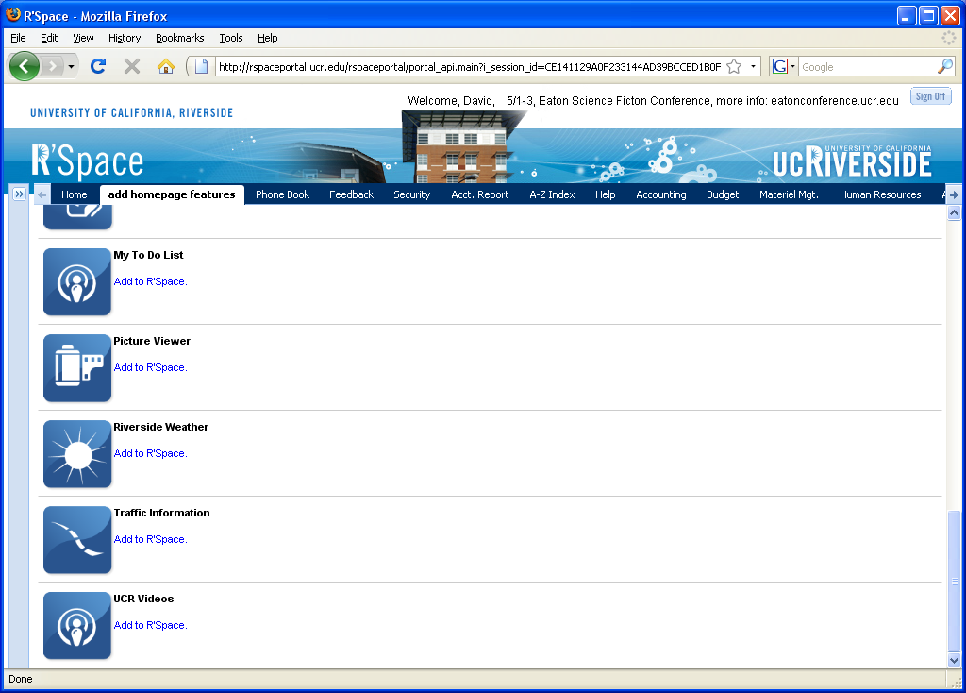

After selecting the desired portlets, they can be moved around and arranged by clicking the portlet title bar and dragging each portlet to its desired location. Similarly, the portlet borders can be clicked and dragged to size each portlet as desired. After each of these actions is performed, AJAX code is executed to update the database with the user’s current settings. This makes the portal layout persistent as the user logs in from one session to the next or from one computer to another.

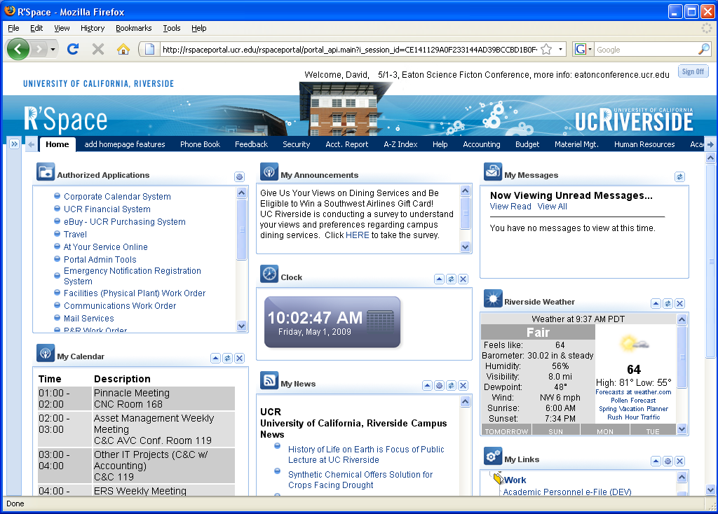

Communication Tools

R’Space features a number of tools for communicating with the campus community. Some of the communications are broadcasted to all users, while others are targeted to specific user populations based upon their attributes.

There are five main communication “channels” within R’Space.

Welcome Message
- 75 characters.
- One message displayed at a time.
- Messages have beginning and end dates.
- Many messages may be “queued” to appear days, weeks, and months in advance.
- Default message (if none exists) is Welcome, First Name.

My Messages
- Many messages may be posted at any one time.
- Messages are automatically archived on their expiration date, regardless of whether or not the message has been read by a particular portal user.
- Unlimited Message Length.
- From and Subject fields have a 256 character limit
- Granular Staff Messaging (by PPS Home Departments, Appointment Types, Personnel Program Codes, Bargaining Units, Title Codes, and EACS Roles)
- Messages may be queued.
- Reader can mark messages as read.
- Beginning and end dates.
- After archived - no display.

My Announcements
- 256 characters.
- Embedded links, formatting.
- One message displayed at a time.
- Beginning and end dates.
- Many messages may be "queued" to appear days, weeks, and months in advance.
- Default message (if none exists) is "There are no announcements to display at this time".

Alerts
- The R’Space will only have a “pop up” alert window for Chancellor, Technical, and Emergency (and not for portal messaging).
- Alert groups are limited to the following: Chancellor, Technical, and Emergency.
- Short Description.
- Long description - 256 characters.
- Active or Inactive
- Beginning and end dates.
- Can be archived.
- Portal Messaging Alerts are also displayed here. These are dynamic, application-specific alerts targeted to the specific user (e.g. You have 2 Travel reimbursements to approve). These include hyperlinks directly to the corresponding application.

Spotlights
- Three events display at a time.
- Thumbnail image (96x44 pixels) and a large image (290x143 pixels).
- Includes a link to a related web page from large image.
- Includes Spotlight name / description (75 characters).
- 3 Spotlights, portal randomizes.
- Beginning and end dates.
- Spotlights may be queued.

The communication channels are identified by number below:
- Welcome Message
- My Messages
- My Announcements
- Alerts
- Spotlights

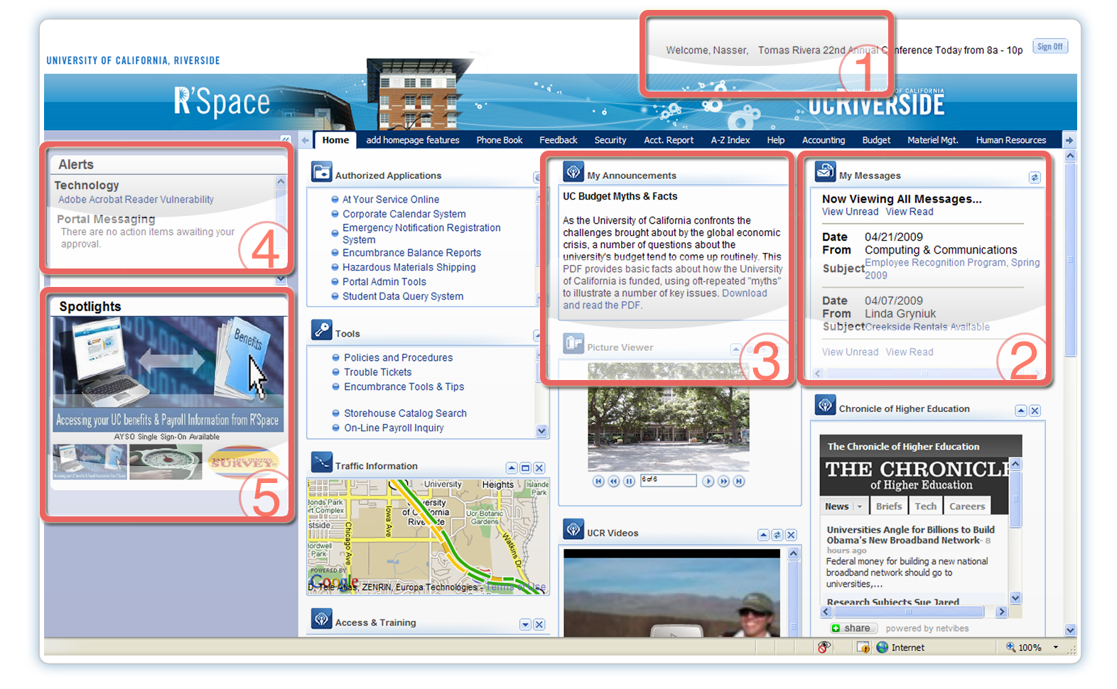

These communication channels are managed via the UCR Portal Administration Tool. Two roles, granted via the Enterprise Access Control System (EACS), are available: Author and Publisher. Authors may create content within the communication channels and Publishers are able to create content and approve it for display within R’Space.
The following screen shows the interface for publishing Spotlights within the portal:
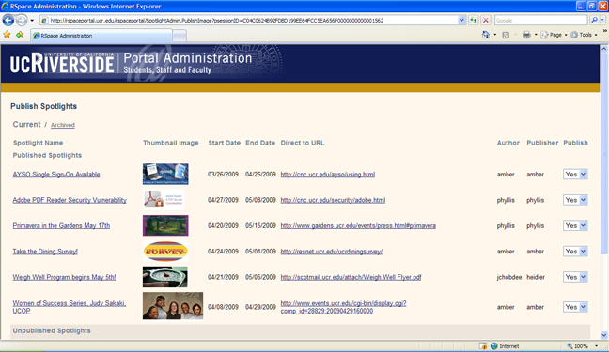

This web site (http://rspace.ucr.edu/admin/) was setup to provide technical support to all Authors and Publishers of the various communication tools for the portal.

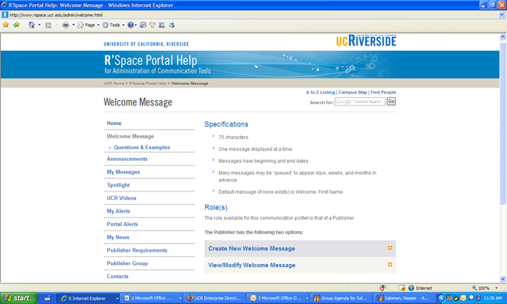

The deployment of R’Space included a governance policy that focused on:
- Allowing key departments/units enough direct access to the new portal communications tools to lessen the use of Scotmail (current email messaging tool via a listserv) and keep the portal content current, fresh, and interesting.

- Providing control / training / oversight to ensure the new portal communications tools do not become new sources of “campus spam”.

It is the role of the Staff Portal Publishers to address these two key portal content needs: to create timely, interesting, and relevant information to be displayed on the portal while not posting information that campus staff will consider “spam”.

Project Team Members (both development & implementation)

Phyllis Bruce Amber Jones Alan Roy
Juan Gonzales Steven Lee Sumita Roy Chowdhury
David Gracey Eric Martin Nasser Salomon
Toni Henderson Larry McGrath Sohail Wasif
Tom Hsu Chuck Rowley

Submitted by:

David Gracey (david.gracey@ucr.edu)
Nasser Salomon (nasser.salomon@ucr.edu)

Objective Customer Satisfaction Data
~~~~~~~~~~~~~~~~~~~~~~~~~~~~~~~~~~~~~~~~~~~~~~~~~~~~~~~~~~~~~~~~~~~~~~~~~~
“Chuck and company, the new portal is terrific. I am actually using the calendar feature.....I keep it right in front of me....and don't get lost going from meeting to meeting. Being able to arrange sections to meet your individual needs is fantastic. Thank you for all of your hard work R'Space.”

Gretchen Bolar, Vice Chancellor, Academic Planning & Budget
~~~~~~~~~~~~~~~~~~~~~~~~~~~~~~~~~~~~~~~~~~~~~~~~~~~~~~~~~~~~~~~~~~~~~~~~~~
“On behalf of the Accounting Office, there was a lot of positive feedback on the ability to sort the Authorized Applications and most liked the ability to customize their views and portlets.”

Bobbi McCracken, Assistant Vice Chancellor, Accounting
~~~~~~~~~~~~~~~~~~~~~~~~~~~~~~~~~~~~~~~~~~~~~~~~~~~~~~~~~~~~~~~~~~~~~~~~~~
“"RSpace" is a statement to the quality of programming and artistic vision at UCR. Great Job! The one enhancement I would suggest would be to embed the Central Authentication Services into the introductory page to save a step in accessing your applications.”

Robert Thompson, Buyer, Plant Administration
~~~~~~~~~~~~~~~~~~~~~~~~~~~~~~~~~~~~~~~~~~~~~~~~~~~~~~~~~~~~~~~~~~~~~~~~~~
“Wow - what a great change - I like being able to customize it, love the weather and the map part and that it is very easy to navigate! Great Job!”

Leslie Ann Webster, Management Services Officer, IGPP
~~~~~~~~~~~~~~~~~~~~~~~~~~~~~~~~~~~~~~~~~~~~~~~~~~~~~~~~~~~~~~~~~~~~~~~~~~
“Congratulation guys!!! I am so happy this is running now. I know it has been a long and hard road, and I am glad I was able to give my two cents. Great work for the whole team!!”

Luis Sanz, Creative Director, Strategic Communications
~~~~~~~~~~~~~~~~~~~~~~~~~~~~~~~~~~~~~~~~~~~~~~~~~~~~~~~~~~~~~~~~~~~~~~~~~~
“This is a fantastic idea. It would be nice if we could make the boxes longer than what you will even allow now. Some of us have quite a few applications and to see them all would be good. Also, if we could link a box for our email that would be the ultimate. Great job!”

Monique Rynders, Management Services Officer, Mathematics
~~~~~~~~~~~~~~~~~~~~~~~~~~~~~~~~~~~~~~~~~~~~~~~~~~~~~~~~~~~~~~~~~~~~~~~~~~
“Working well. I would prefer to log in at the R'Space main page.”

Russell Lewis, Director of Materiel Management, Purchasing
~~~~~~~~~~~~~~~~~~~~~~~~~~~~~~~~~~~~~~~~~~~~~~~~~~~~~~~~~~~~~~~~~~~~~~~~~~
“Thanks for adding a link to the Phone Book. R'Space is already great. Now this feature makes it even better.”

Millie Garrison, Financial and Administrative Office, Entomology
~~~~~~~~~~~~~~~~~~~~~~~~~~~~~~~~~~~~~~~~~~~~~~~~~~~~~~~~~~~~~~~~~~~~~~~~~~
“I love the picture viewer; it adds a personal touch to the Work Space”

Mela Fezzey, Recruitment Services Operations Supervisor, Human Resources
~~~~~~~~~~~~~~~~~~~~~~~~~~~~~~~~~~~~~~~~~~~~~~~~~~~~~~~~~~~~~~~~~~~~~~~~~~

