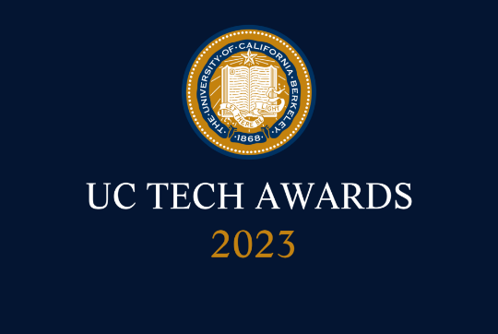
UC Tech Awards 2023 Candidate
Category: SUSTAINED IMPACT
Name: Angela (Angie) Rossi Steele, Director of IT, Baskin Engineering (1)
Number of people: (1)
Location: UC Santa Cruz
- Person submitting the application/nomination
  - Rebecca Alley, Web Developer, Baskin Engineering, UC Santa Cruz, Staff
  - Email address: rsalley@ucsc.edu
  - The name of your organization: UC Santa Cruz

- Award category: Sustained Impact

- Name of person, name of the team, or name of the project to receive the award : Angela (Angie) Rossi Steele

- All project team members - not applicable

- Which location was affected by the work? UC Santa Cruz / Baskin School of Engineering | Information Technology Service

- Summary
Angie’s dedication, work ethic, and wisdom makes her a 1-in-a-million genius in her divisional liaison role.

- Narrative
  - Angela’s dedication, work ethic, and wisdom makes her a 1-in-a-million genius in her divisional liaison role.
  - Angela has been part of the ITS and education world for over 25 years.
  - Please see her work at her LinkedIn profile: https://www.linkedin.com/in/angela-rossi-steele
  - For more information to help you create this narrative, please scroll below to learn more about each award category.

