  
**UC Tech Awards 2023 Candidate**

**Category:** SUSTAINED IMPACT

**Name:** Joshua Swink, Programmer Analyst, Office of Information Technology  
**Number of people:** (1)  
**Location:** UC Merced

1. **Person submitting the application/nomination**
   1. **Name, title, department, location/organization, and please indicate if you are faculty or staff:** Christy Snyder, Assistant Vice Chancellor and Deputy Chief Information Officer, UC Merced Office of Information Technology (staff)
   2. **Email address:** csnyder4@ucmerced.edu
   3. **The name of your organization:** UC Merced
2. **Award category:** Sustained Impact
3. **Name of person, name of the team, or name of the project to receive the award:** Joshua Swink, Programmer Analyst, Office of Information Technology
4. **All project team members - if applicable** N/A
5. **Which location was affected by the work?** UC Merced
6. **Summary**   
   Josh has been part of UC Merced since the very beginning....literally! Josh transferred to UC Merced as a member of the very first undergraduate cohort in 2005 and joined the UC Merced Office of Information Technology as an employee in 2007. His thoughtful, pragmatic approach and expertise in the UC Merced ecosphere have made him an integral member of the UC Merced Identity and Access Managment (IAM) services team. Though they might not know it, his work has significantly improved at least one—if not many—process/es that affect every member of our campus community.
7. **Narrative**

UC Merced’s strategic goals include growing enrollment and attaining R1 status, and we can say with confidence that when the campus attains those goals, it will be due at least in part to the contributions Josh Swink has made in streamlining student, faculty, and staff processes.   
  
Josh has been part of UC Merced since the very beginning....literally! Josh transferred to UC Merced as a member of the very first undergraduate cohort in 2005 and joined the UC Merced Office of Information Technology as an employee in 2007. Josh is a member of the Identity and Access Managment (IAM) services team and one of UC Merced's senior software engineers and application architects, having served the campus for sixteen years and counting. He most enjoys back-end development, but has great user empathy that helps the Office of Information Technology group continually improve our front-end user experiences.

Josh was integral to our 2022 UC Tech award-winning work to re-imagine our Statement of Intent to Register (SIR) process for UC Merced applicants and built the checklist that helps students advance through the requirements associated with undergraduate admission and financial account management throughout their time as students on our campus.   
  
Josh’s longevity with our campus can now be measured by the processes he first envisioned and built for us over a decade ago, and has now rebuilt in newer, more modern applications. For example, Josh created the interface that allows the UC Merced Admissions department to message student applicants and admits in our student portal back in 2013, and he rebuilt a new interface when we migrated from the portal to our campus app in 2020.

He has also maintained and upgraded the software that helps students claim UC Merced accounts, built and implemented multiple tools that allow faculty to manage grade and enrollment processes in our campus Learning Management System (LMS), CatCourses, and acted as the senior back-end engineer on all our work over the past few years to build next-generation interfaces for our campus Directory, Single Sign-On, and IAM self-service.  
  
In Josh's career at UC Merced Office of Information Technology, he has built top-level software solutions and automations across the campus for Admissions, Registrar, Financial Aid, Schools, Information Security, Learning Management Systems, for students, parents/guardians, faculty, staff and affiliates. During his tenure, he has built significant expertise in the UC Merced ecosphere and he is the grounding force on project teams—always keeping the team centered on the realities of our environment and coming up with creative and innovative solutions to deliver on project requirements.

He does all this with a matter-of-fact attitude and thoughtful, pragmatic approach. Josh is always one of the smartest people in the room, but he is also very humble, and he is happiest when he’s solving problems on his own or with our small team. In fact, he will probably hate that we have nominated him for this award, and will accept it only because he has to. But Josh deserves to be recognized for his commitment to UC Merced. His dedication and hard work have impacted literally every member of the UC Merced community in one way or another.   
  
Some of Josh’s career highlights to date:

* implemented the Mid/Final Grades Tool (2015). This tool allows faculty to submit mid-semester and final grades using grade data from their courses in CatCourses (Canvas), ability to set overrides, and set dates of last attendance.
* implemented the CatCourses Enrollment Tool (2016). This automation reads course enrollments from the Banner SIS to CatCourses in order to create courses and assign roles for access.
* implemented the Faculty Drop Tool in CatCourses (2016). This allows faculty to see student activity in CatCourses and drop students for non-attendance.
* built UCM's Student Enrollment Checklist (2013). This tool, used by all admits and undergraduate students at UC Merced, helps to shepherd students through the various processes and procedures necessary to progress through their undergraduate career such as completing Financial Aid requirements, completing Student Health requirements, managing financial holds, and more.
* Built the Admission’s Director's Student Message platform (2013). This tool allows Undergraduate Admissions to easily message applicants and provide them with relevant information as they move through the application process and become new Bobcats.

More recently, Josh was the senior back-end developer for UCM's new Directory application (<https://directory.ucmerced.edu>) and the award-winning student SIR experience (<https://decision.ucmerced.edu>). Josh's latest work can be found on UCM's next generation IAM self-service application (<https://mercedid.ucmerced.edu>).

In addition to all the projects and roles articulated above, Josh has developed numerous custom web applications and system integrations for the campus, and he continually supports the campus IAM services team, providing technical guidance, ensuring service reliability, and improving SSO account management for the campus.

To sum up: if there is a software problem to solve quickly or a new automation that will improve a student, faculty, staff experience at UC Merced, Josh has always been and will continue to be part of the solution. We are so grateful that he has dedicated his career thus far to improving the UC Merced technical landscape, and wecan’t wait to see what he’ll do next.  
  
Some examples of Josh’s work:   
  
UC Merced Connect App Checklist:   
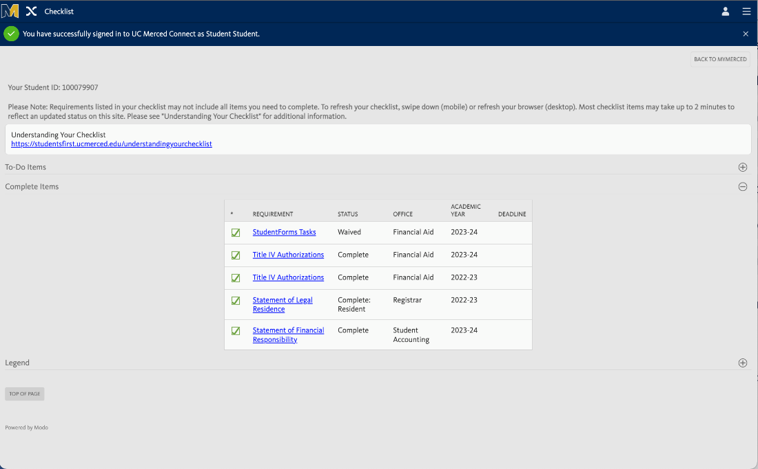

UC Merced Directory :



UC Merced Identity & Access Self-Service Application:



UC Merced Statement of Intent to Register (The Road to UC Merced):

