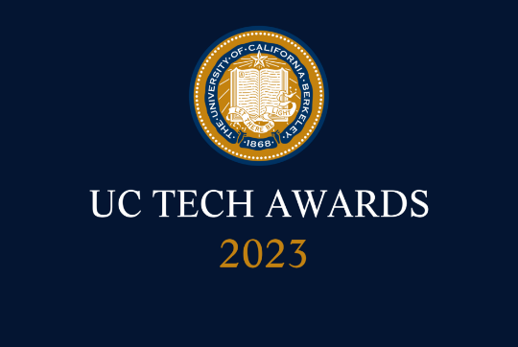
UC Tech Awards 2023 Application
Category: .SUSTAINED IMPACT + DEI LEADERSHIP
Name: Mary Northup, Identity and Access Services Architect (1)
Number of people: (1)
Location: UC Davis

- Person submitting the application/nomination
  - Nan Jiang, Applications Programmer, UCDavis/IET, staff
  - Email address: nanjiang@ucdavis.edu
  - The name of your organization: (i.e. UCLA) UCDavis

- Award category Sustained Impact Award

- Name of person, name of the team, or name of the project to receive the
Mary Northup

- All project team members - if applicable (n/a).

- Which location was affected by the work? (the name(s) of the organization affected)
UCDavis
- Summary (1-3 sentences synthesizing the longer “Narrative - see below)
Mary Northup's long-standing commitment, diverse expertise, and the numerous successful projects she has led make her a deserving candidate for the Sustained Impact Award. I believe that honoring Mary with this prestigious award will not only recognize her exceptional contributions but also inspire others to follow in her footsteps.

- Narrative (1.5-2 pages in Word - up to about 1,000 words- feel free to include visuals). This is a descriptive narrative about the person/team (and their portfolio of work - or the initiative/project - in terms of the selection criteria for that award. Please include:
  - Description of the initiative(s) or portfolio of work that supports the nomination based on the award description.
  - How they meet selection criteria (complexity, impact, and mission alignment).
  - How their success is measured/quantified.
  - The time during which the work was done.
For more information to help you create this narrative, please scroll below to learn more about each award category.

I am writing to nominate Mary Northup, IT Architect (Supervisor) in the Identity Access Management (IAM) team, for the Sustained Impact Award. Mary has consistently demonstrated significant expertise, passion, and commitment to the University of California throughout her tenure, with a diverse portfolio of work supporting the technology arena.

Complexity:
Mary has tackled a wide range of complex projects, including leading the development of the Clover processes for managing data from multiple sources and feeding it to downstream campus applications. Her attention to detail has been critical in handling complex data cases and ensuring the accuracy and integrity of the source data. In addition, Mary played a key role in the new WarnMe system, managing the process of sending collected data to the third-party vendor, Everbridge, for emergency alert distribution.

Impact:
Mary's work has had a significant and lasting impact on the campus. She has been involved in numerous essential projects, such as the implementation of the new TAF system for sponsoring external employees, the maintenance and upgrade of Campus Authentication Services (CAS), and the management of IAM and IET APIs for authorized clients to access PII data. Furthermore, her diligent work on the lived name project has helped to embrace UC's "Gender Recognition and Lived Name" policy, fostering a more inclusive environment for all members of the university community.

Mission alignment:
Throughout her career, Mary has actively contributed to the advancement of the university's mission and key values of access, affordability, and excellence. Her leadership in projects such as the Clover processes, the new WarnMe system, and the lived name project has not only enhanced the technology infrastructure but also improved the overall campus experience for faculty, staff, and students. Her unwavering dedication to the university and its technology arena has significantly supported the institution's growth and development.

