

**UC Tech Awards 2023 Candidate**

**Category:** OPERATIONAL EXCELLENCE  
**Name:** Hospital Epidemiology and Infection Prevention (HEIP) Surveillance and Clinical Analytics team (4)  
**Number of people:** (4)  
**Location:** UCSF Health

1. **Person submitting the application/nomination**
   1. Lusha Wang, MPH, CIC  
      Surveillance and Clinical Analytics: Clinical Informatics Analyst

Department of Quality – Hospital Epidemiology and Infection Prevention

UCSF Health   
Staff

* 1. **Email address:** lusha.wang@ucsf.edu
  2. **The name of your organization:** UCSF Health

1. **Award category:** Operational Excellence
2. **Name of person, name of the team, or name of the project to receive the award**:  
   The Analysts within Hospital Epidemiology and Infection Prevention (HEIP) Surveillance and Clinical Analytics team
3. **All project team members:**
   1. Catherine Zhuang
      1. Surveillance and Clinical Analytics: Clinical Informatics Analyst
      2. Department of Quality – Hospital Epidemiology and Infection Prevention
      3. UCSF Health   
         Staff
   2. Edward Koo
      1. Surveillance and Clinical Analytics: Clinical Informatics Analyst
      2. Department of Quality – Hospital Epidemiology and Infection Prevention
      3. UCSF Health   
         Staff
   3. Lusha Wang
      1. Surveillance and Clinical Analytics: Clinical Informatics Analyst
      2. Department of Quality – Hospital Epidemiology and Infection Prevention
      3. UCSF Health   
         Staff
   4. Kim Stanley
      1. Surveillance and Clinical Analytics: Manager
      2. Department of Quality – Hospital Epidemiology and Infection Prevention
      3. UCSF Health
      4. Staff
4. **Which location was affected by the work?**
   1. **All UCSF Health locations:**
      1. UCSF Parnassus
      2. UCSF Mission Bay
      3. UCSF Mt Zion
      4. UCSF Benioff Children’s-Oakland
5. **Summary**

Healthcare-associated infections (HAIs) can be severe and life-threatening. Accurate and timely access to meaningful HAI outcomes is an essential foundation for all prevention efforts. UCSF Health is committed to monitoring and reporting HAIs into the CDC’s National Health Safety Network (NHSN), the nation’s most comprehensive medical event tracking system. Although NHSN's web-based system allows healthcare facilities to enter and benchmark their data by comparing reported events to predicted numbers of infections, availability of NHSN results can be delayed, impacting the timeliness and infection prevention interventions. Our project automated NHSN’s extensive risk model calculations within our database, reducing our reliance on NHSN's web services and manual report generation, and improving our ability to prevent future infections.

1. **Narrative**

**Background**   
Healthcare-associated infections (HAIs) pose a threat to patient safety, quality and cost of care at any healthcare facility. At UCSF Health, preventing and reducing HAIs is a top priority, as reflected in our organizational goal to achieve zero harm. The FY23 UCSF Health organizational goal for quality and safety includes reduction in four HAIs out of the seven focused harm types.  
  
NHSN is currently used by over 16,000 healthcare facilities and it has successfully generated summary measures from its vast data collection to help track healthcare associated infections (HAIs) at national, state and local levels over time. These summary measures include Standardized Infection Ratios (SIR) and Standardized Utilization Ratios (SUR) that compare the actual number of reported events to the number predicted based on risk-adjusted national baseline data. Healthcare facilities can use these measures to trend their progress as well as benchmark against other institutions with comparable patient populations.   
  
**Business Process**   
UCSF Department of Quality and Safety’s Hospital Epidemiology and Infection Prevention (HEIP) Surveillance and Clinical Analytics (SCA) team is responsible for monthly mandated reporting HAI events to NHSN through Epic’s Infection Control (Bugsy) module. However, this process is manual and repetitive, making it prone to human error and reliant on the availability of NHSN's web servers. Additionally, certain limitations in NHSN's web portal require manual manipulation of pre-existing reports desired output. Access to sensitive protected health information (PHI) data in NHSN is restricted to a limited group of people at UCSF, but data accessibility is critical to track our HAI reduction efforts.  
  
To overcome these challenges, we started automating the NHSN summary measure calculations in November 2021, beginning with the SIRs calculations for three of the four organizational focused HAIs: central line-associated bloodstream infections (CLABSI), catheter-associated urinary tract infections (CAUTI) and *Clostridioides difficile* infections (CDI). We have also completed SUR automation for central line, catheter, and ventilator days as of April 2023. We will use the CLABSI SIR calculation as an example under methods.  
  
**Methods**  
SIR is calculated from dividing the number of observed infections by the number of predicted infections. The number of observed infections is what a facility reports. The number of predicted infections is computed from multivariable regression models using nationally aggregated data during a baseline period, which is NHSN’s 2015 collected national data. NHSN uses either a logistic regression model or negative binomial regression model based on the infection outcome type. Logistic regression models are used when there is an opportunity for a single outcome after exposure e.g., a surgical site infection following a surgery whereas negative binomial regression models are used when estimating incidence from an overall population e.g., CLABSIs in critical care units. These models are applied to a facility’s denominator data corresponding to the infection event type along with risk factor parameters to output a predicted number of infections (CDC NHSN, 2022). NHSN publishes its regression model calculations and parameters in its analysis resource documents.   
  
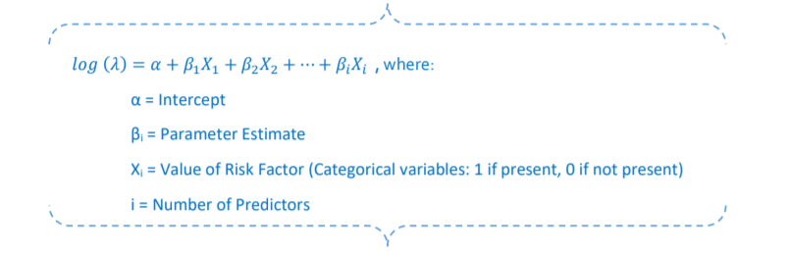Figure 1. The general formula for the negative binomial regression model published in the NHSN SIR Guide April 2022.  
  
The parameters for the risk adjusted factors included in the SIR calculation are also published by NHSN. Using CLABSI SIR as the example, the 2015 baseline is adjusted based on the following variables found to be statistically significant predictors for acute care hospitals: location type (based on patient population), facility bed size, teaching institution/medical school affiliation and facility type reported at NHSN enrollment.  
  
Our primary software application tool is a Microsoft Structured Query Language (SQL) database, which we use to transform NHSN published surveillance elements into various database objects, specifically reference tables. Tables are fundamental to any relational database because they allow data to be organized in a row-and-column format, where each row represents a unique entity and each column represents a field within the entity. These tables are the building blocks for what we need to calculate SIRs outside of the NHSN portal. SQL queries give us the flexible to re-create the NHSN’s formula once we program the input values from existing tables containing observed infection denominators and numerators and the newly built NHSN’s SIR parameters reference tables.   
  
The following figures provide an overview of data flow process and some of the database objects needed for calculating CLABSI SIRs.

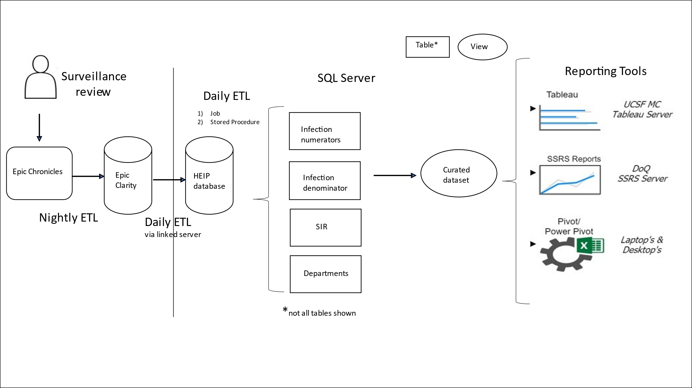  
Figure 2a. Automation overview for extracting, transforming and loading (ETL) required data points for SIR calculation outside of the NHSN web portal.

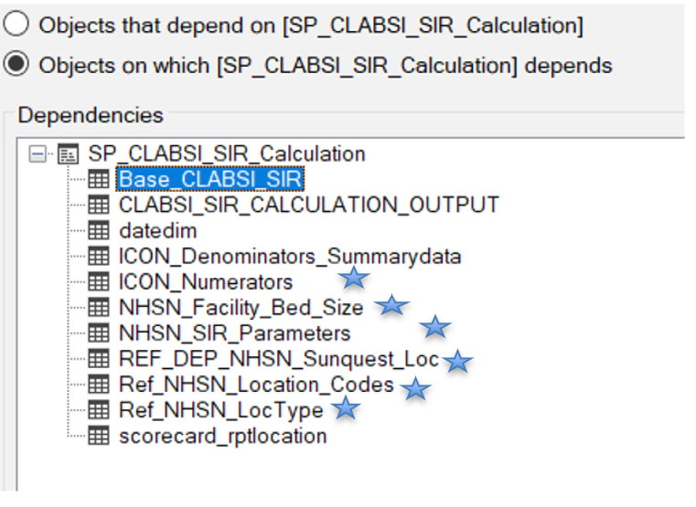  
Figure 2b. Six reference tables* were created to assist in the Stored Procedure (SP) containing programming for regression model formula.

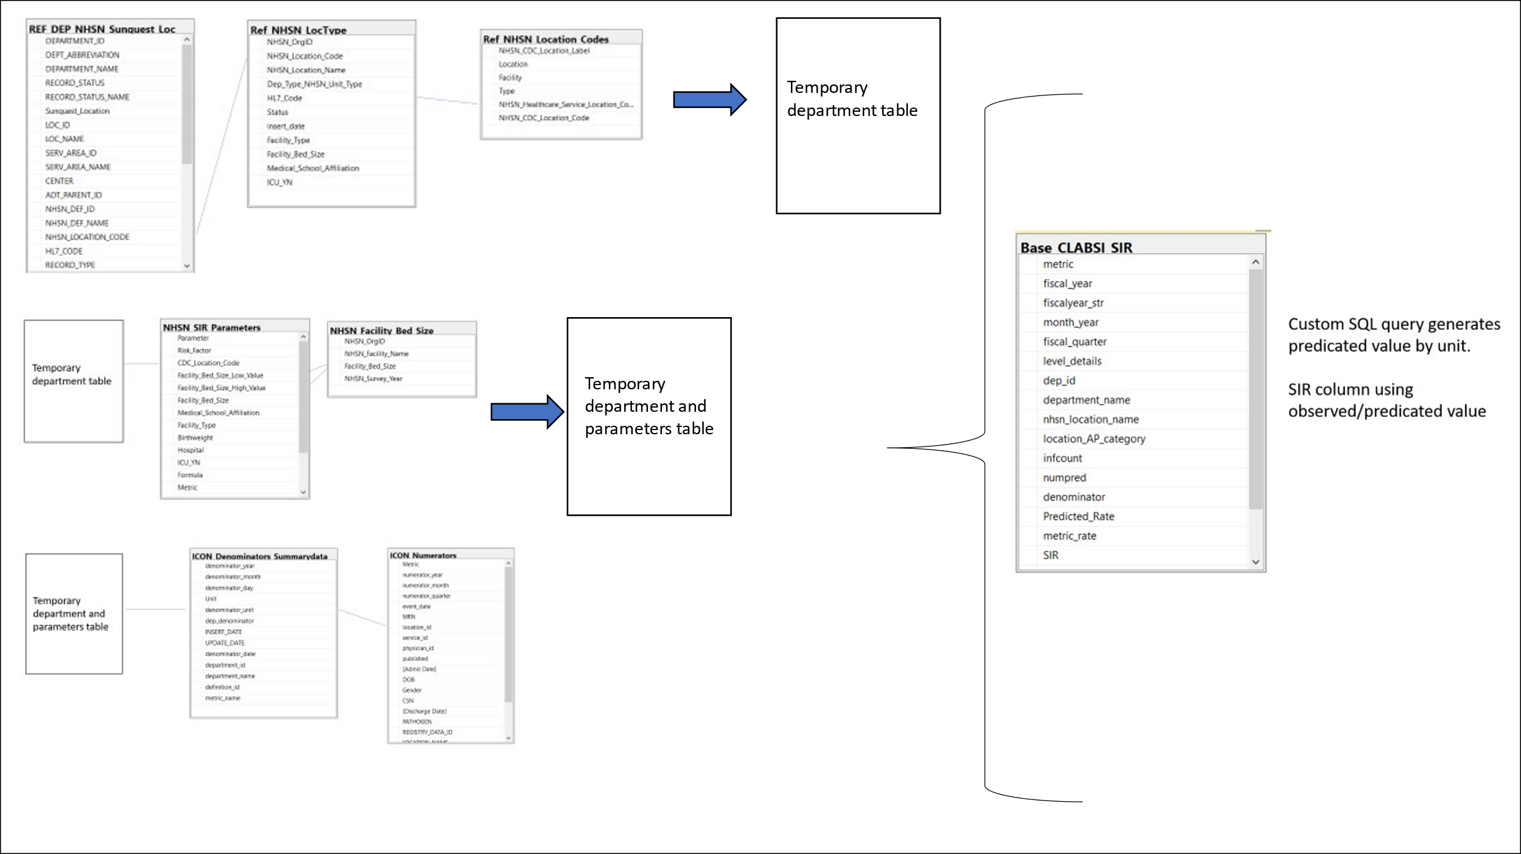  
Figure 2c. A simplified entity-relationship (ER) diagram highlighting how key tables are used in calculating the predicted CLABSI value by location.  
  
**Business Impact**   
The automation of core SIR tables has had a significant positive impact. By replacing the need for monthly FTE resources to manually manipulate and download 12 NHSN reports (three infection types for four facilities: Parnassus, Mission Bay, Mt Zion and BCH-Oak), we increased operational efficiency and reduced the potential for human error. We also eliminated the need for manual intervention work by directly linking the data sources feeding our enterprise dashboards to these core tables.   
  
Another key benefit from this automation is the ability to generate predicated events when we anticipate changes to known risk model variables before updating publicly reported records within NHSN. For example, we can calculate predicated events for newly opened units or units that are planning for re-opening to serve a different patient population, which can be advantageous for financial planning.   
  
In addition to the importance of HAI outcomes and analyses for patient safety, these measures also have major regulatory, financial and reputational impacts. HAI outcomes are used by the Centers for Medicare & Medicaid Services (CMS)’s to determine Hospital-Acquired Condition (HAC) Reduction Program penalties, by the California Department of Public Health to evaluate for healthcare facility deficiencies, and by organizations such as Leapfrog and Vizient to publicly grade the performance of healthcare facilities’ performance in comparison to others.

**Future Development**We recognize that all data systems are subject to continuous evolution and NHSN’s data models are no exceptions. However, our current data architectural design allows us to easily update tables’ content with minimal disruption to the existing datasets.  
  
In the coming months, we will finalize the automation of Targeted Assessment for Prevention (TAP) NHSN reports. The TAP reports use a metric called cumulative attributable difference (CAD), which is the number of infections that must be prevented to achieve an HAI reduction goal. The automation of CAD, SUR SIR summary measures will provide valuable insights to UCSF Health, as we strive to improve health outcomes and work towards our goal of achieving zero harm.

**References**

1. Center for Disease Control - National Healthcare Safety Network. (January 2023). *Patient Safety Component Manual*. <https://www.cdc.gov/nhsn/pdfs/pscmanual/pcsmanual_current.pdf>
2. Center for Disease Control - National Healthcare Safety Network. (April 2022). *The NHSN Standardized Infection Ratio (SIR): A Guide to the SIR*. <https://www.cdc.gov/nhsn/pdfs/ps-analysis-resources/nhsn-sir-guide.pdf>
3. Center for Disease Control - National Healthcare Safety Network. (April 2022). *The NHSN Standardized Utilization Ratio (SUR): A Guide to the SUR*. <https://www.cdc.gov/nhsn/pdfs/ps-analysis-resources/nhsn-sur-guide-508.pdf>