**UC Tech Awards 2023 Candidate**

**Category:** OPERATIONAL EXCELLENCE  
**Name:** Richard Dunning, Sr Apps Programmer and Irene Chen, Information Systems Analyst (2)  
**Project:** Creation of a “self-service” portal  
**Number of people:** 2-7  
**Location:** UC San Diego

1. **Person submitting the application/nomination**
   1. Irene Chen, Information Systems Analyst, ITS, UC San Diego, Staff
   2. **Email address:** ihchen@ucsd.edu
   3. **The name of your organization:** UCSD
2. **Award category** Operational Excellence
3. **Name of person, name of the team, or name of the project to receive the award** Richard Dunning and Irene Chen
4. **All project team members - if applicable** (Name, title, department, location/organization, and please indicate if they are faculty or staff, along with their email address(s).
   1. Richard Dunning, Sr Apps Programmer, ITS, UCSD, Staff, [rdunning@ucsd.edu](mailto:rdunning@ucsd.edu)
   2. Irene Chen, Information Systems Analyst, ITS, UC San Diego, Staff, [ihchen@ucsd.edu](mailto:ihchen@ucsd.edu)
   3. Shruti Bhakta, Sr Accountant, Business and Financial Services, UCSD, Staff, [sbhakta@ucsd.edu](mailto:sbhakta@ucsd.edu)
   4. Marissa Prough, Assoc Director, Business and Financial Services, UCSD, Staff, [mprough@ucsd.edu](mailto:mprough@ucsd.edu)
   5. Eric Del Rosario, Project Mgr, Business and Financial Services, UCSD, Staff, [edelrosario@ucsd.edu](mailto:edelrosario@ucsd.edu)
   6. Cheryl Kaino, Sr Dir/Fin Info Svcs, ITS, UCSD, Staff, [ckaino@ucsd.edu](mailto:ckaino@ucsd.edu)
   7. Erika Szewczyk, Bus Sys Analyst Supv, ITS, UCSD, Staff, [eszewczyk@ucsd.edu](mailto:eszewczyk@ucsd.edu)
5. **Which location was affected by the work?** (Internal)Recharge organizations at UCSD
6. **Summary** The creation of a “self-service” portal which allows internal recharge organizations the ability to upload and validate their recharge transactions was a process efficiency that resulted in significant time saved for both the initiators (recharges) as well as Central Office users.
7. **Narrative**

**Description / Background:**

At UC San Diego, recharge organizations provide goods and/or services internally to other groups or departments. Recharges are responsible for processing their own transactions, but security limitations prevent them from importing transactions directly into the financial system. The workaround solution was for recharge users to populate an import file and submit a support case to have Central Office users import the file on the recharge’s behalf. In addition to the import file being complex and confusing, the “paper pushing” act of importing files was a poor use of Central Office users’ time and expertise, especially when it required multiple back and forth communications to resolve file errors.

The creation of the RMP Recharge Application solved the issue by creating a self-service portal which included a simplified import file and a limited number of validations to flag errors upon attempted import. This allowed recharge users to quickly populate the import file, but to also troubleshoot their own errors in real time. This removed the Central Office users as the middle person for the majority of groups and allowed them to instead spend their time on the subset of groups who had more complex import requirements and truly needed assistance.

**Selection Criteria:**

This effort meets the criteria based on an improved business process that resulted in improved speed, efficiency and effectiveness. It was also scalable, as the application was intended for a single department with less than 10 recharge organizations and is now used by more than 250 groups.

**Success:**

The success was measured in two parts: 1) the amount of time required to populate the new simplified import file and 2) the number of support cases related to importing transactions. See graphs for more information. At the time of the Lean Six Sigma Green Belt project (November 2021), based on the number of groups onboard at that time, the amount saved is ~12,000 hours or ~$288,000 a year.

**Timeframe:**

The application was built specifically for RMP department users when Oracle went live in July 2020, but RMP graciously agreed to scale access to the portal to other campus recharges, with the main onboarding effort concluding July 2021.

Diagram 1: Time to populate the import file dropped off in August 2021. The average time to populate file dropped from 5.1 hours to 1.2 hours.

Diagram 2: The total cycle time started to decrease in July 2021. The cycle time (i.e., a ready to import file to validating completed transactions) dropped from 43 hours (5.3 days) to .3 hours.

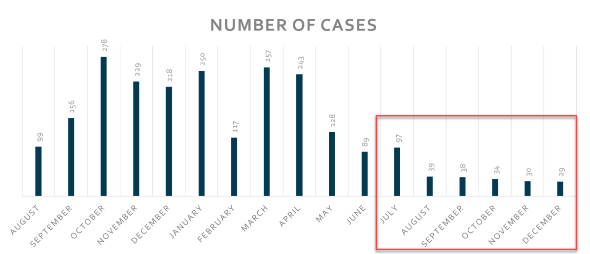

Diagram 3: The number of support cases started to decrease in May 2021 when the onboarding effort started, and stabilizing in August 2021 to less than 40 cases through the end of the year. Empowering recharge users to manage import and troubleshooting reduced the number of cases by 86%.