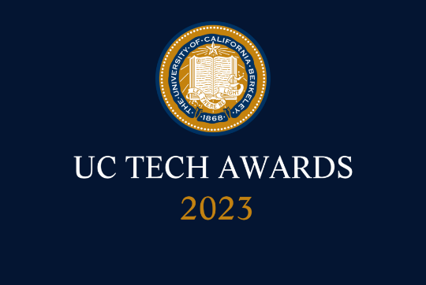
UC Tech Awards 2023 Candidate
Category: OPERATIONAL EXCELLENCE
Name: Identity Access Management (IAM) team
Number of people: (6)
Location: UC Davis
- Person submitting the application/nomination
  - Nan Jiang, Applications Programmer, UCDavis/IET, staff
  - Email address: nanjiang@ucdavis.edu
  - The name of your organization:UCD

- Award category Mojgan Amini Operational Excellence Award

- Name of person, name of the team, or name of the project to receive the award Identity Access Management (IAM) team

- All project team members - if applicable (Name, title, department, location/organization, and please indicate if they are faculty or staff, along with their email address(s).
Mary Northup, IT Architect, UCDavis/IET, staff, mnorthup@berkeley.edu
Nan Jiang, Applications Programmer, UCDavis/IET, staff, nanjiang@ucdavis.edu
Laxmi Charita, Applications Programmer, UCDavis/IET, staff, lpotarlanka@ucdavis.edu
Sandeep Vaitla, Applications Programmer, UCDavis/IET, staff, svaitla@ucdavis.edu
Armando Mota, Applications Programmer, UCDavis/IET, staff, arjmota@ucdavis.edu
Anitha Kumar, Applications Programmer, UCDavis/IET, staff, abkumar@ucdavis.edu

- Which location was affected by the work? (the name(s) of the organization affected)
UCDavis

- Summary: IAM team's outstanding work in transforming the Online Directory application exemplifies the qualities recognized by the Mojgan Amini Operational Excellence Award. Their achievements in overcoming complex challenges, making a significant impact on the university community, and advancing the university's mission and values make them deserving recipients of this prestigious award.
- Narrative
I am writing to nominate the Identity Access Management (IAM) team, consisting of Mary Northup, Nan Jiang, Laxmi Charita, Sandeep Vaitla, Armando Mota, and Anitha Kumar, for the Mojgan Amini Operational Excellence Award. This highly dedicated team has transformed the Online Directory application at UCDavis, significantly enhancing its reliability, speed, scale, efficiency, and effectiveness.

Complexity:
The IAM team faced a complex challenge in overhauling the old Online Directory system, which was partially reliant on unsupported third-party software (AMCOM). They were tasked with not only modernizing the system but also replacing the unsupported components with in-house solutions. The team successfully navigated these challenges, delivering a more robust and user-friendly system to the university community.

Impact:
The transformation of the Online Directory application has had a wide-ranging impact on UCDavis campus and UCD Health. The new system provides an improved user interface, benefiting thousands of students, faculty, and staff who rely on it to update their personal and directory information. The enhanced privacy controls allow users to choose the accessibility of their directory data. In embracing the "Gender Recognition and Lived Name" policy, the team has also created a more inclusive environment for all users. The successful replacement of the unsupported AMCOM components has ensured the continuity of this critical service.

Mission alignment:
The IAM team's efforts to transform the Online Directory application directly align with the university's mission to provide access, affordability, and excellence. By developing a more reliable, efficient, and user-friendly system, they have enabled students and faculty to easily access and update their information, supporting their academic and research pursuits. Their dedication to inclusivity, as demonstrated by the implementation of the "Gender Recognition and Lived Name" policy, further reflects the university's commitment to fostering a diverse and welcoming community.

