**UC Tech Awards 2023 Form**

**Category: IT SECURITY  
Name:** Rubrik Implementation Team

**Number of people:** 3 + all staff UCR School of Medicine **Location:** UC Riverside

1. **Person submitting the application/nomination**
   1. Simon Linwood, School of Medicine, staff
   2. **Email address:** Simon.Linwood@ucr.edu
   3. **The name of your organization:** UCR
2. **Award category** IT Security
3. **Name of person, name of the team, or name of the project to receive the award**

Rubrik Implementation Team

1. **All project team members - if applicable** 
   1. Jeff Flogerzi [Jeff.Flogerzi@medsch.ucr.edu](mailto:Jeff.Flogerzi@medsch.ucr.edu)
   2. Armando Gauna [armando.gauna@medsch.ucr.edu](mailto:armando.gauna@medsch.ucr.edu)
   3. Matthew Summerville [Matthew.Summerville@medsch.ucr.edu](mailto:Matthew.Summerville@medsch.ucr.edu)

All staff of School of Medicine, UCR

1. **Which location was affected by the work?** (the name(s) of the organization affected)

UCR School of Medicine and UCR Health

1. **Summary** The IT Security Award Nomination is a recognition for the UCR School of Medicine's IT team's successful implementation of Rubrik to ensure the confidentiality, integrity, and availability of sensitive information. Led by Armando Gauna, Jeff Flogerzi, and Matthew Summerville, the team's collaboration and unwavering commitment have modernized the data security tools and improved the data recovery infrastructure, enabling cutting-edge research and clinical care for underserved communities in the Inland Empire.
2. **Narrative**

The UCR School of Medicine serves the healthcare needs of underserved communities in the Inland Empire by training a diverse workforce of physicians and scientists, conducting groundbreaking research, and providing high-quality clinical care. Data security is critical to the operation of the School of Medicine at UCR as it ensures the confidentiality, integrity, and availability of sensitive information such as clinical data, research data, and financial information.

Established 10 years ago, the UCR SOM has been in need of modernizing its data security tools. By implementing Rubrik, the IT team at UCR SOM is able to uphold data integrity, deliver data availability, withstand adverse conditions, and restore businesses with their data when infrastructure is attacked, thus enabling the advancement of cutting-edge research and clinical care in the underserved communities of the Inland Empire.

The successful implementation of Rubrik at the UCR School of Medicine was achieved through the unwavering commitment and collaboration of the IT security team. Armando Gauna led the vendor selection, Jeff Flogerzi led the implementation and test, and Matthew Summerville set the security policy, each bringing their unique expertise to the project and working together seamlessly to achieve the common goal of ensuring the safety and integrity of critical data.

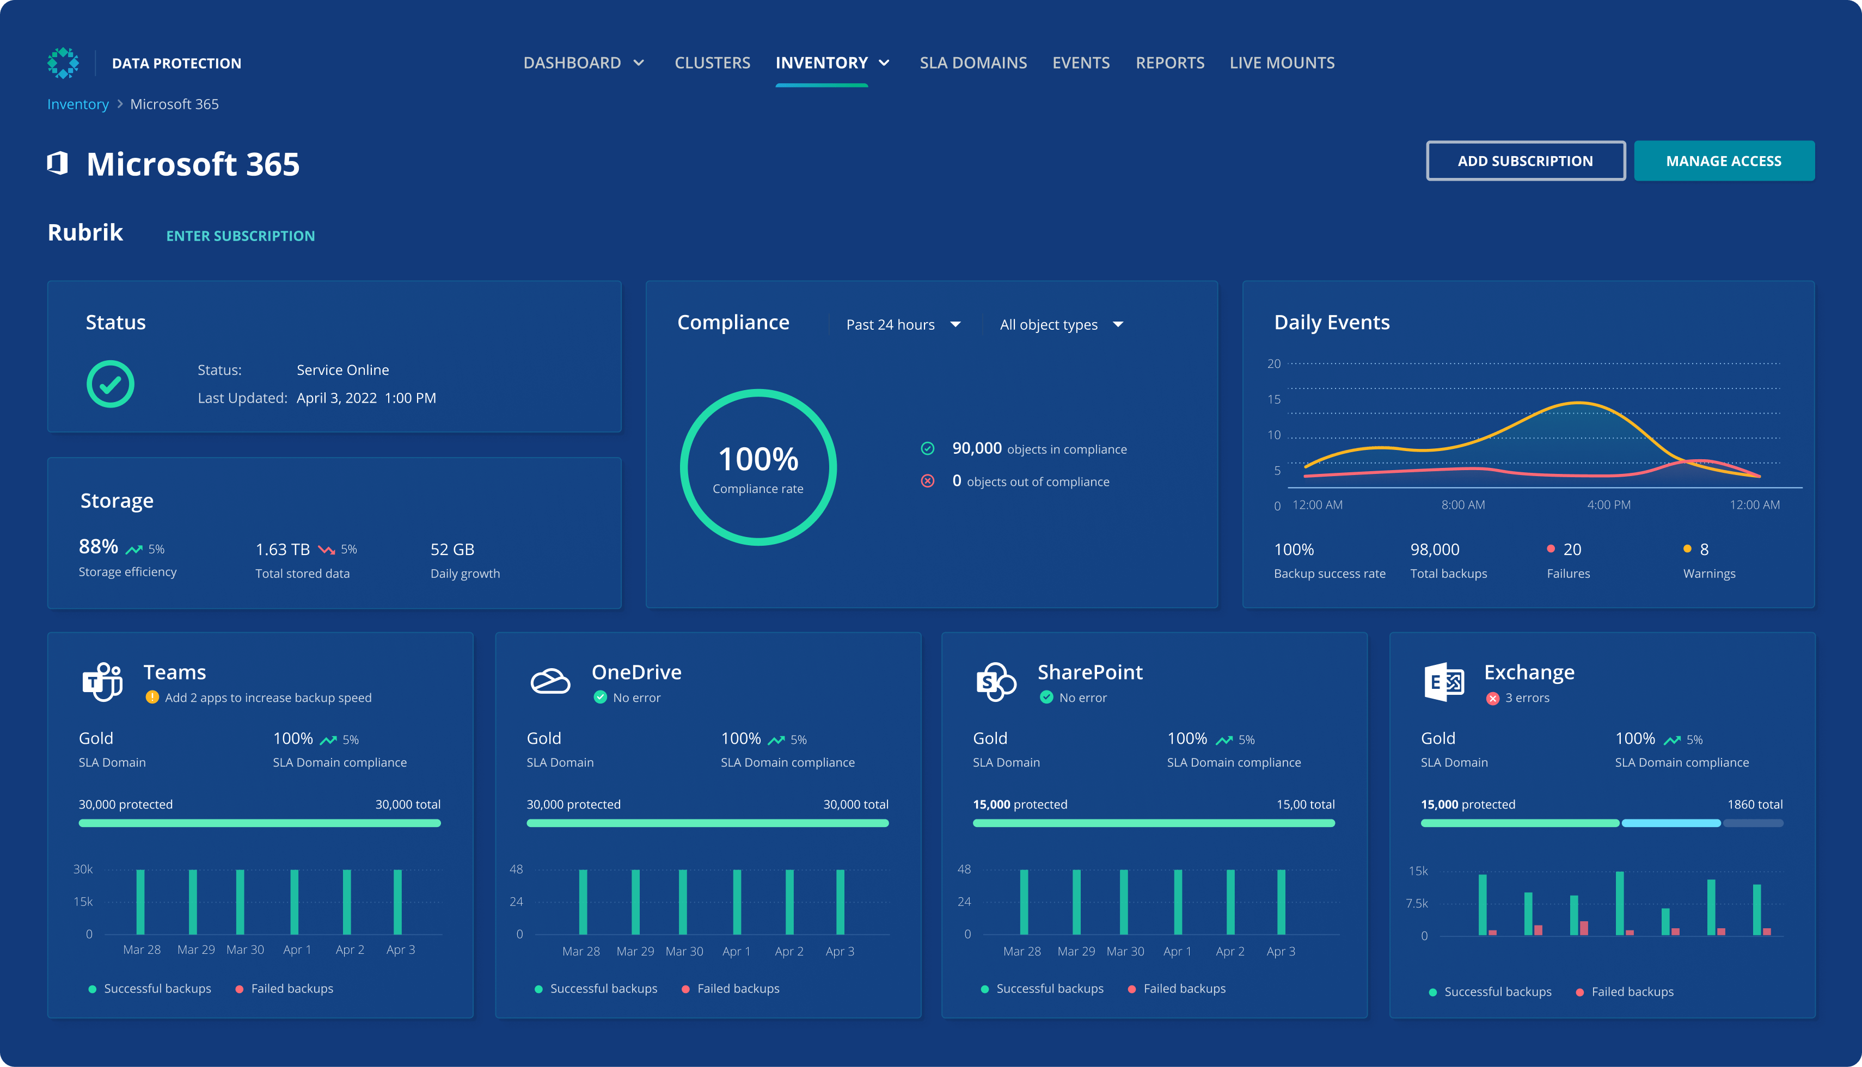

They demonstrated their dedication by starting with a proof of principle study with the vendor, thoroughly testing the product, and swiftly transitioning into full implementation in 2022. As a result, the data recovery infrastructure was critically improved and resulted in a good rating in the external audit.

This approach showcases the team's determination to ensure the confidentiality, integrity, and availability of sensitive data within the UCR School of Medicine. Their commitment to data security sets an excellent example and is deserving of recognition.