**UC Tech Awards 2023 Candidate**

**Category:** INNOVATION **Name:** Francesca Albrezzi, Digital Research Consultant and Joy Guey, Emerging Technologies Advocate (2+100) **For the project:** Fostering Collaboration through the XR Initiative (Francesca Albrezzi, Digital Research Consultant and Joy Guey Emerging Technologies Advocate (2+100)  
  
**Location:** UCLA

1. **Submitter:** Chris Cabrera Thompson, IT Manager, Department of English & Writing Programs, UCLA (Staff)  
   Email: ccthompson@english.ucla.edu
2. **Category:** Innovation in IT
3. **Name of people/project:** Fostering Collaboration through the XR Initiative  
   Francesca Albrezzi, Digital Research Consultant  
   UCLA Office of Advanced Research Computing  
   &  
   Joy Guey, Emerging Technologies Advocate  
   UCLA Social Sciences Center for Education Research and Technology
4. **Working Group Members (**[**100+ faculty/staff on maillist**](https://ucla.box.com/s/ps5g8n8vctxh378pihyjw8tc3slykc04)**); Timeline: April 2019-Ongoing**
5. **UCLA Campus**
6. **Summary** Over the last year Francesca and Joy have led the UCLA XR Initiative to build community, expose research, and build campus resources around XR technologies. Their efforts over the last year have created a UCLA wide community of professionals working together to support Faculty research leveraging XR technologies and have built a powerful community of IT professionals who are starting to collaborate and build institutional knowledge to support the UCLA mission.

**Narrative**   
  
**PROJECT SUMMARY**

Over the last year, Francesca and Joy have led the UCLA XR Initiative to build community, expose research, and

build campus resources around XR technologies. Their efforts have created a powerful UCLA-wide community of

professionals working together to support faculty research leveraging XR technologies to build institutional

knowledge and embrace the UCLA mission.

● A single point of contact/funnel that can point individuals to the right direction

● Reduces overhead for incoming students, faculty, and staff to find XR resources

● Fosters ongoing collaboration across all departments involved with XR ranging from medical, arts,

humanities, social sciences, and engineering.

● Establish a solid baseline to solicit support and financial investment from leadership on our campus

**PROBLEM STATEMENT**

Many departments and project teams across our campus have long recognized the impact that extended reality

technologies (umbrella term for virtual and augmented reality) would have on academic research and pedagogy.

However, there had always been a lack of communication across disciplines and a lack of infrastructure to

support the ongoing work on campus. And because there wasn’t a clear place, even online, to point people in the

right direction, it became difficult for anyone who wanted to learn more about XR technologies to find a place to

convene and explore the uses that can stem from these transformative tools. After a [Virtual Reality Institute Task](https://evcp.ucla.edu/wp-content/uploads/2020/10/Virtual-Reality-Task-Force-Report-Feb-2019.pdf)

[Force Report](https://evcp.ucla.edu/wp-content/uploads/2020/10/Virtual-Reality-Task-Force-Report-Feb-2019.pdf) was released at the start of 2019, a few campus members decided to take it upon themselves to

begin an initiative and start a network to foster interdisciplinary collaboration in the XR space.

**INNOVATION & COLLABORATION**

Through these grassroot efforts, the core team has evolved over the years and gathered enthusiastic support

from faculty, staff, and students from diverse backgrounds. They started by launching a website to post related

events on campus and in the greater LA area, arranged open hour tours of active labs using XR equipment

across campus, and put together events on campus to highlight the research that has been done and spark

further conversations around the use of XR tools. This also included a digital map of XR labs across campus with

contact information, so that faculty and students could have a better understanding of where they could access

resources and support for XR work. Although the pandemic placed a pause on in-person events, the team was

adamant about keeping the momentum going and decided to put together a couple of virtual events. The [TDG](https://tdg.ucla.edu/xr-arts-and-humanities)

[Webinar](https://tdg.ucla.edu/xr-arts-and-humanities) brought together faculty in the Arts and Humanities who have been using XR in their teaching and

research which garnered interest from over 100 attendees from multiple campuses and the XR industry who

voiced their [thoughts](https://public.tableau.com/views/TDGXRWebinar/PollResults?:showVizHome=no) around the explosive growth of XR. Francesca and Joy created multiple Mozilla Hub

environments to house the presentations and showcase student work from courses that taught XR ( [TDG Webinar](https://hubs.mozilla.com/Nc3qKwL/ucla-tdg-webinar)

and the [Bruinverse](https://hubs.mozilla.com/LnsxJmS/bruinverse) from the first annual [3D/XR Day](https://sites.google.com/g.ucla.edu/uclaxrday2022/home?authuser=0) ). While many were dealing with zoom fatigue, they were able

to leverage these interactive environments to immerse viewers and make the content exciting and accessible for

anyone to view on different platforms.

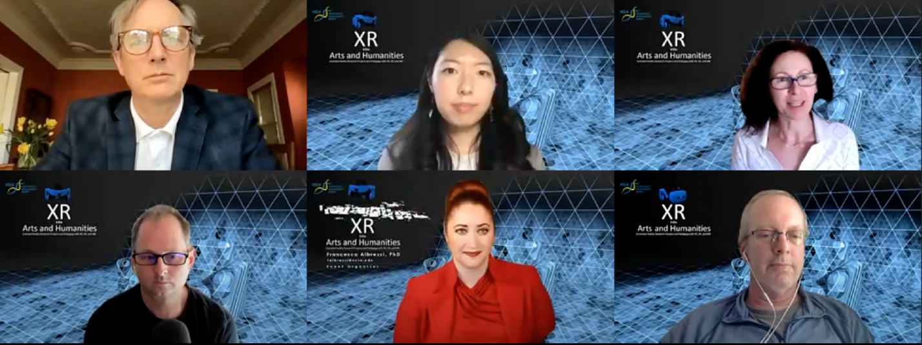

*To keep up with the fast-paced nature of this form of technology, the team re-convened to kick off a series of*

*monthly working group meetings that started in June of last year. The purpose of these meetings were to develop*

*and share working knowledge and standards for XR usage in instruction and research at UCLA. They would*

*assess, review, explore, discuss, and share the results of using XR technology to improve teaching and facilitate*

*academic research. For example, Joy and Francesca led the effort to produce a shared XR equipment list to*

*evaluate what resources were available for use across campus, and to help other departments consider how to*

*invest their funds to buttress and not duplicate what is already available to students and faculty. The team used*

*Google Drive and Slack to record and disseminate information and make these resources accessible to everyone*

*involved with the working group. As word began to travel, these working group sessions began to attract*

*interested members from the XR industry and other campuses.*

***IMPACT***

*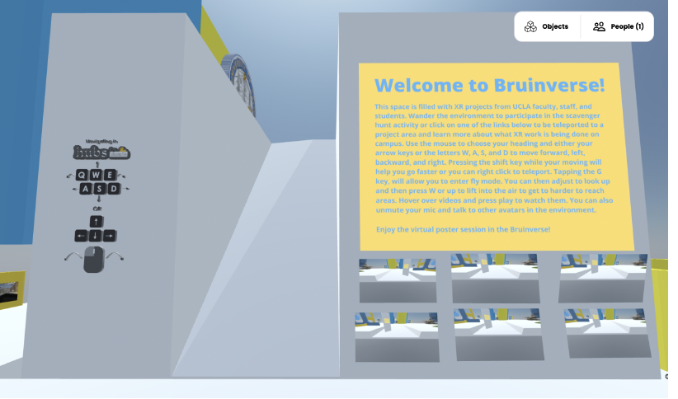Over the past year, the working group members have*

*been able to invite guest speakers from NVIDIA, XR*

*startups, and other academic institutions, who have*

*graciously volunteered their time to come and share*

*new resources and what they’ve been working on.*

*Because of this collaborative effort to continue*

*meeting and discussing the uses of XR, these*

*sessions have quickly become a welcoming space for*

*anyone regardless of experience to come and ask*

*questions, share work, and grow together. Both*

*undergraduate and graduate students have found this*

*working group as a place to join ongoing projects to*

*gain working experience, or showcase their prototypes to gain feedback from experts. Faculty have found*

*hardware resources, grant sources, and have been able to recruit other faculty and staff to join each other’s*

*courses for final presentations. Staff have started circulating a campus hardware inventory list to consolidate*

*resources and joined lively discussions around important topics such as accessibility, terminology, assessment*

*and efficacy of XR usage in classrooms. All of these methods have strengthened relationships among colleagues*

*and bridged the gaps between departments that may have never had the opportunity to cross paths.*

*Although the impact can not be quantified as a metric, the XR initiative has succeeded in its goal to create a*

*sense of belonging and a judgment-free zone to push the limits of XR research, pedagogy, and design. Their*

*hope with sharing this across the UC system is that this model can be improved upon and possibly implemented*

*in other campuses for other innovative technologies such as AI. Their goal is to continue to spark enthusiasm and*

*collaboration across the UC campuses in terms of XR support and development, working toward founding a*

*network similar to the* [*UC GIS working group*](https://uc-gis-ucop.hub.arcgis.com/) *.*

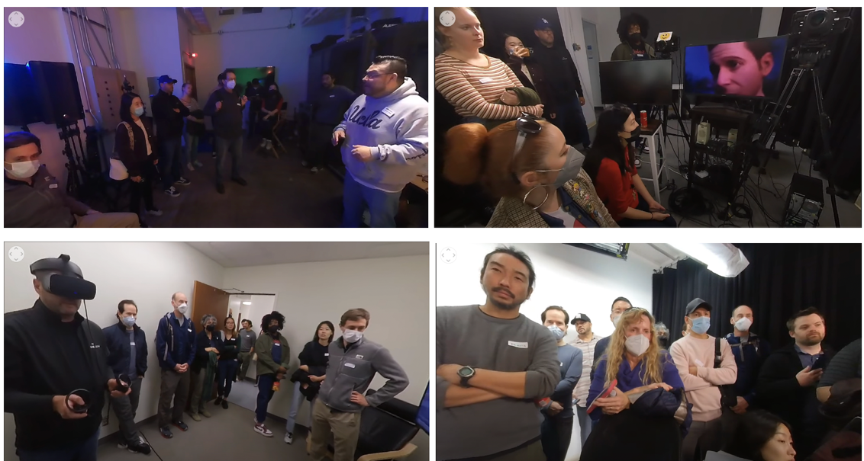

*Photos above include 360° snapshots from our Holiday Crawl Dec. 2022 and screenshots below show the folder structure for the XR Initiative and Working Group*  
  
  
