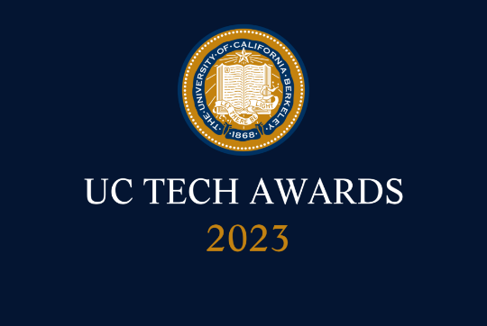
UC Tech Awards 2023 Candidate
Category: INNOVATION
Name: Student Technology Equity Program (3)
Number of people: (3)
Location: UC Berkeley.
- Person submitting the application/nomination
  - Anne Marie Richard, Associate CIO and Director, Student Affairs IT (Staff)
  - anne_richard@berkeley.edu
  - UC Berkeley

- Award category: INNOVATION

- Name of person, name of the team, or name of the project to receive the award:

  - Student Technology Equity Program

- All project team members - if applicable
  - Luz Contreras Corona, Program Coordinator, Student Affairs IT (Staff)
  - Cristobal Olivares, Director, Student Technologies, Student Affairs IT (Staff)
  - Anne Marie Richard, Associate CIO and Director, Student Affairs IT (Staff)

- Which location was affected by the work?
  - UC Berkeley

- Summary
  - The pivot to online instruction as a result of the COVID-19 pandemic highlighted the fact that not all UC Berkeley students have adequate technology to support remote teaching and learning. Many students relied on campus-provided wi-fi, software in on-campus computing labs, and short-term laptop loans from departments or the library, and when the pandemic forced the closure of campus, these resources were no longer available. The Student Technology Equity Program (STEP) was created in Spring 2020 to provide graduate student instructors and low-income undergraduate and graduate students the essential technology (i.e., laptops, tablets, wi-fi hotspots, and peripherals such as headphones and web cameras) they needed. From March 2020 to June 2022, STEP distributed a total of 9,378 pieces of technology hardware to 4,971 students. In Fall 2022, this program successfully transitioned from a COVID-relief effort to an ongoing program that continues to address student success by providing necessary technology to students with financial need so that they can engage fully in research, teaching, and learning.

- Narrative

The Student Technology Equity Program is an innovative technology initiative that has had a significant impact on the university’s academic/research mission and student life. STEP was developed in just a matter of weeks after the pandemic began, and in its first two years, served nearly 5,000 students with need directly, and also enabled the installation of campus network in the UC Berkeley Family Housing complex that previously lacked this service, thus serving the residents of these 975 apartments.

Initially sponsored by the CIO and the Vice Provost for Undergraduate Education, this project was immensely successful and was a true campus collaboration: one-time funding came from numerous sources, including central campus funding, the Student Technology Fund, the New Student Services unit in Student Affairs, and the Basic Needs Center.

With a significant return to in-person instruction in Fall 2021, STEP evolved to fit the current needs, focusing on highest-need students only, redeploying returned devices to eligible new applicants, and hiring additional student staff to accelerate response and turnaround time. The program staff developed a multi-layered outreach and communication plan to ensure that as many undergraduate and graduate students, advisors, staff, and faculty were aware of the program and how to access its services. Key communication channels were established (website, email account, voice line) and strategic messaging was disseminated throughout the campus community, including:

● Notifications to all students via CalMessages (campus-wide communications), CalCentral
(student portal) and bCourses (learning management system)
● Recurring announcements to departments/units that communicate with large populations of eligible students, including Basic Needs Center; bridges Multicultural Resource Center; Cal NERDS; Centers for Educational Equity & Excellence (CE3); Centers for Educational Justice & Community Engagement; Disabled Students’ Program; Financial Aid & Scholarships Office; Graduate Division
● Program information and updates to colleagues in ASUC; Communications & Public Affairs; Division of Student Affairs; Graduate Assembly; LEAD Center; New Student Services; Research, Teaching & Learning; Student Union; as well as posts sent to advisingmatters and teach-net participants
● Direct outreach to new Summer Bridge students in concert with the Student Learning Center

These partnerships - with dozens of departments and programs from academic and administrative divisions throughout the campus - have been essential to STEP’s success.

Overwhelmingly, students report a high level of satisfaction with, and gratitude for, the technology received through STEP.

In students’ words:

“It has allowed me to take part in my student experience and academics and has given me direct access to my courses, assignments, graduate student meetings and duties, etc. It has [helped] my education this year as without it, I wouldn't have been able to attend or have had significant barriers in accessing my courses and responsibilities as a student.“
-- Graduate student, Bioengineering

“The STEP program has taken care of everything I needed to make the transition to an online environment be easy and accessible. I have a reliable laptop that allows me to properly attend all my courses and supports my assignment needs. The headsets were lifesavers and [allowed] me to focus on my lectures and communicate smoothly as well.”
-- Undergraduate student, Political Science

“At the start of the pandemic, I was using my personal laptop a lot more than usual, so it quickly began to have issues. Being loaned a laptop through STEP was a lifesaver, especially when I was at a point in time where I could not afford a new device. Thank you for offering this service, I cannot imagine getting through my undergrad without this program. I have now officially graduated and I credit where I am to STEP!”
-- Undergraduate student, Biology

In Summer 2022, UC Berkeley leadership approved the Instructional Resilience and Enhancement Fee, which included permanent funding for STEP. The program is now managed by Student Affairs IT, and this academic year to date has served over 900 students. It continues to expand hardware offerings and explore additional technology equity initiatives for students in need.

For more information about this exceptional program that is truly making a difference in the student experience, please visit https://studenttech.berkeley.edu/step

t

