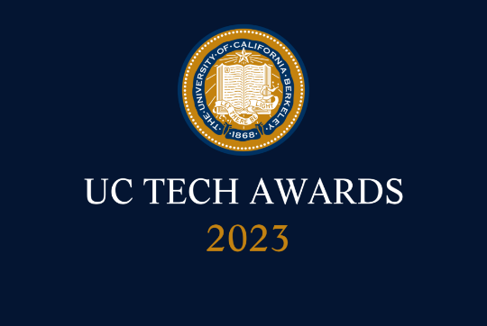
UC Tech Awards 2023 Candidate
Category: DEI LEADERSHIP
Name: Sarvani Chadalapaka, Director of Research Computing (1)
Number of people: (1)
Location: UC Merced
- Person submitting the application/nomination
  - Nick Dugan, Vice Chancellor and Chief Information Officer, UC Merced, Staff
  - Email address: ndugan@ucmerced.edu
  - The name of your organization: UC Merced Office of Information Technology

- Award category: DEI Leadership* (*Individuals only)

- Name of person, name of the team, or name of the project to receive the award Sarvani Chadalapaka

- All project team members - if applicable N/A

- Which location was affected by the work? UC Merced

- Summary

Sarvani Chadalapaka has spent her entire career as a tireless advocate for women in technology and supporting various DEI-focused initiatives in her field of research computing. As an invited speaker, committee chair, program developer, mentor, and institutional leader, she has created communities of support for underrepresented groups across the higher education community and at UC Merced.

- Narrative

Please accept my enthusiastic nomination of Sarvani Chadalapaka, Director of Cyberinfrastructure and Research Technologies at UC Merced, for the UC Tech Diversity, Equity, and Inclusivity (DEI) Award. Sarvani is a true leader in promoting diversity, equity, and inclusion in the research computing community both at UC Merced and across higher education. UC Merced serves a highly diverse population – over 70% of our students are first generation, and more than 80% are from historically under-represented groups. Sarvani’s efforts to create a welcoming and inclusive space for students, faculty, and researchers have been invaluable in accelerating research computing support and utilization at UC Merced.

Sarvani’s work promoting diversity, equity, and inclusivity extends beyond UC Merced. She is an ardent advocate for early-career women in High Performance Computing (HPC) and created a worldwide HPC mentorship program (WHPC-Mentoring Program) for early career women in HPC with the Women in HPC organization. This initiative operates across 5 continents, over 25 countries, and with over 60 volunteers. Sarvani's leadership and vision have helped create mentorship opportunities for women in HPC to thrive and succeed.

Sarvani's commitment to DEI is also reflected in her work at conferences and events. Her passion for promoting a supportive and inclusive environment is further demonstrated in her role as the DEI Co-Chair at a national research computing conference called Practice and Experience in Advanced Research Computing (PEARC). As DEI Co-Chair, she has been a tireless advocate for creating a more inclusive environment in the research computing community. Her work alongside her co-chair to advocate for on-site childcare and dependent care grants for attendees at the PEARC conference has been significant in reducing barriers to attendance for early career attendees who may have otherwise faced challenges in balancing their professional responsibilities with their caregiving responsibilities. Sarvani's leadership in this area has been instrumental in laying the foundation for future years of the conference. The DEI Chairs of subsequent PEARC conferences have used the groundwork that Sarvani established to provide dependent care grants to attendees.

Sarvani was awarded the Internet2 Inclusivity Initiative (I2I) Scholarship Award in 2017 for her efforts to promote diversity in the research computing community. She remained connected to I2I in later years, serving on the steering committee as both a Co-Chair and a member, with the goal of building a stronger community among I2I recipients and beyond. I2I focuses on creating opportunities for professional networking and career development, especially for individuals who are underrepresented in the field. By connecting with role models, mentors, advocates, and allies, they can receive valuable support and guidance to advance their careers.

Sarvani's efforts to promote diversity, equity, and inclusion in the research computing community have earned her invitations to speak and participate in panel discussions at a wide range of conferences. Sarvani has been invited to speak at conferences such as PEARC, UCTech, Super Computing, UC-Ref, ACI-Ref, Virtual Residency, and Internet2 TechEx, among others. Her talks primarily focus on building and bridging research computing communities, mentorship opportunities for early-career women, and navigating IT careers as an early-career woman in tech.

Back home at UC Merced, Sarvani has made a significant impact on increasing the number of researchers using high performance computing (HPC). In just four years, she was able to increase the number of researchers using core HPC resources from 40 to 600, including a 900% increase during her first year. Her efforts in developing training and outreach strategies for a diverse set of researchers, and translating their research needs to infrastructure solutions have been invaluable in reducing barriers to high performance computing. She has recently focused significant efforts to collaborate with faculty and administration to propose and establish new academic programs, including a Data Science and Computing degree in UC Merced’s School of Natural Sciences.
Overall, Sarvani’s unwavering commitment to promoting diversity, inclusivity, and equity in the research computing community makes her an exceptional candidate for the UC Tech DEI Award. Her achievements and leadership both at UC Merced and across the higher education research community are commendable and fully embrace UC Merced’s Principles of Community and the UC system’s goals of Access, Affordability, and Excellence. She is an invaluable member of OIT’s senior leadership team and has quickly developed a reputation as a capable collaborator and principled advocate for women in technology. Her efforts in building the nascent HPC community at UC Merced and her ongoing work to promote diversity and inclusivity in the field make her a true asset to the University of California and the broader research computing community; her nomination for this award receives my strongest support and endorsement.

