UC Tech Health Awards Program 2023 Candidate

Category: DEI LEADERSHIP
Name: Laona Beouf
Number of people: (1)
Location: UCLA Health

Submitter: Kyrie Bass, Manager, UCLA Health IT, kbass@mednet.ucla.edu
Award Category: DEI Leadership Award
Nominee: Laona LeBeouf
Location: UCLA Health
Summary:
Laona LeBeouf has led UCLA Health IT diversity, equity, and inclusion efforts to help transform the organizational culture into a welcoming and inclusive environment for all. Her leadership efforts include planning and hosting monthly EDI Listen and Learn sessions and partnering with UCLA Health Talent Acquisition to develop and implement EDI Recruitment Best Practices.
After the murders of George Floyd and Breonna Taylor, UCLA Health IT employees were horrified and angry, as much of the country was, and wanted to take action to make a difference. Through this upsurge, the organization created various mechanisms for employees to engage including EDI Listen and Learn sessions, the Black Advocacy Workgroup, and Patient Advocacy Through Technology team. UCLA Health IT also created an Anti-Racism plan in conjunction with Health EDI (HEDI). After the initial groundswell, participation and involvement started to wane, and Laona searched for ways to keep employees engaged in DEI. In Winter 2022, she created an annual content schedule for the monthly Listen and Learn sessions, and increased communication on the department EDI Teams channel to promote each session and encourage attendance and participation. Laona worked with the team to ensure that the learning content was relevant and valuable, and identified various ways for attendees to interact before, during and after each monthly session. Laona also reached out to HEDI to inquire about another effort, Chats for Change, to see if Health IT could combine efforts to synergistically deliver DEI learning to a broader audience in the future. Laona continues to create opportunities for Health IT to get actively involved in DEI efforts by encouraging employees to develop a “call to action” which are shared in the monthly Listen and Learn sessions.
In alignment with the UCLA Health IT Anti-Racism plan, the organization sought out ways to improve processes for recruiting, hiring, and retaining best talent. Collaborating with UCLA Health Talent Acquisition, a standardized recruitment process was developed to ensure the all recruitments are consistent and fair. In March 2022, Laona led efforts to finalize and implement the new recruitment model and created and delivered training to our management team on DEI recruitment best practices. She developed a DEI resource page which includes the UHIT Recruitment Plan Template, recommended anti-bias training, and DEI interview questions. She also offered one-on-one coaching and unit-level training for areas that needed additional support.
In October 2022, Laona led the initiative to create training for Health IT managers and supervisors so that they would feel more comfortable leading DEI conversations with their teams. The training included resource tools and the opportunity to practice during the session. The leadership team then regrouped a few months later to talk about how their conversations were going and helped to create a stronger bond between the leaders in seeking out peer support and guidance in the future.
When UCLA Health rolled out the Transforming Our Community training, Laona ensured that the organization was successful in reaching participation goals for the training. As a result, Health IT achieved over 99% completion rate for all Health IT employees by the first due date of January 31, 2022.

Laona has a passion for helping others, and this enthusiasm is exemplified in her leadership role for UCLA Health IT summer internship programs. Laona leads UCLA Health IT’s involvement in the Allied Turner Internship program (hosted by UCLA Health). The program is designed to address workforce shortages and offers career education for students from under-resourced communities who express interest in learning about health care career opportunities. Laona works tirelessly to identify hosts, help with matching interns, providing hands on support to hosts, coordinating the tour and panel discussion, and personally ensuring that participants have a meaningful learning experience during their visit.
Through her commitment to DEI and the many initiatives that Laona has headed, UCLA Health IT’s organizational maturity with DEI has grown and expanded. Laona’s leadership and partnership with teams such as HEDI/JEDI ensure that DEI will not only remain top of mind but will also be sustainable over time.

Laona leading UCLA Health IT panel for Allied Health interns – Summer 2022
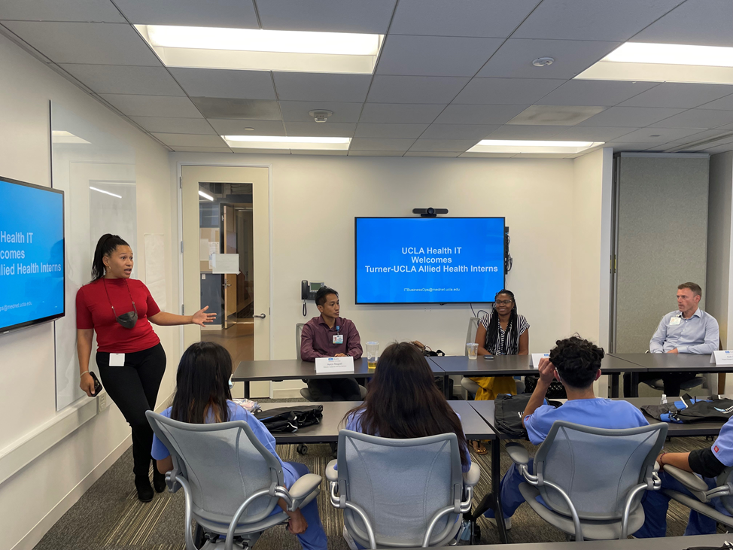
Summary Statement:
Laona LeBeouf has led UCLA Health IT diversity, equity, and inclusion efforts to help transform the organizational culture into a welcoming and inclusive environment for all. Her leadership efforts include planning and hosting monthly EDI Listen and Learn sessions and partnering with UCLA Health Talent Acquisition to develop and implement EDI Recruitment Best Practices.
Blog Article:
After the murders of George Floyd and Breonna Taylor, UCLA Health IT employees were horrified and angry, as much of the country was, and wanted to take action to make a difference. Through this upsurge, the organization created various mechanisms for employees to engage including EDI Listen and Learn sessions, the Black Advocacy Workgroup, and Patient Advocacy Through Technology team. UCLA Health IT also created an Anti-Racism plan in conjunction with Health EDI (HEDI). After the initial groundswell, participation and involvement started to wane, and Laona searched for ways to keep employees engaged in DEI. In Winter 2022, she created an annual content schedule for the monthly Listen and Learn sessions, and increased communication on the department EDI Teams channel to promote each session and encourage attendance and participation. Laona worked with the team to ensure that the learning content was relevant and valuable, and identified various ways for attendees to interact before, during and after each monthly session. Laona continues to create opportunities for Health IT to get actively involved in DEI efforts by encouraging employees to develop a “call to action” which are shared in the monthly Listen and Learn sessions. Other DEI efforts include:
- In March 2022, Laona led efforts to finalize and implement the new recruitment model and created and delivered training to our management team on DEI recruitment best practices.
- In October 2022, Laona led the initiative to create training for Health IT managers and supervisors so that they would feel more comfortable leading DEI conversations with their teams.
- When UCLA Health rolled out the Transforming Our Community training, Laona ensured that the organization was successful in reaching participation goals for the training. As a result, Health IT achieved over 99% completion rate for all Health IT employees by the first due date of January 31, 2022.
- Laona has a passion for helping others, and this enthusiasm is exemplified in her leadership role for UCLA Health IT summer internship programs, including Allied Turner Internship program which is designed to address workforce shortages and offer career education for students from under-resourced communities.
Through her commitment to DEI and the many initiatives that Laona has headed, UCLA Health IT’s organizational maturity with DEI has grown and expanded. Laona’s leadership and partnership with teams such as HEDI/JEDI ensure that DEI will not only remain top of mind but will also be sustainable over time.

