Central Bank Module – Campus/OP Department User Guide
Endowment & Investment Accounting Online System (EIAOnline)
Last modified: 8/13/2012

Contents

General Information 3
Process Flow for an Authorization Request 5
Process Flow for a Loan Request 6
Process Flow for an Transaction Request 7
Getting Started 8
Activities 8
Authorization 8
View Authorization 9
Requesting a New Authorization 11
Loans 14
View Existing Loans 14
Requesting a New Loan 17
Transactions 21
View Transactions 21
Requesting a New Transaction 24
Reports 27
View Reports 28

General Information

The EIAOnline Central Bank module provides users direct access to create, update, review, and approve/reject campus/OP department Authorization, Loan, and Transaction requests. Campus /OP department users have three menu options in the module – Authorization, Loan, and Transaction Maintenance. These requests are submitted for UCOP approval; the UCOP Capital Markets Finance group is the UCOP approver. The UCOP Endowment & Investment Accounting group is responsible for the monthly Central Bank processing. Central Bank processing occurs on the 1st business day of the month for the prior month. For instance, the September 2012 Central Bank processing will occur on 10/1/2012. Once the monthly processing is complete, a system generated email will be sent to inform users of the process completion and that the TISADV files are available in the FTP server.
Central Bank permissions for campus/OP departments are communicated from the Capital Markets Finance group to the EIAOnline Systems Administrator. Read only access is available – campuses/OP departments must provide a list of users who require (1) request submission permission and (2) read only permission to the Capital Markets Finance group. An EIAOnline Administrator can also be contacted by sending an email to eia@ucop.edu. If permissions are granted while your EIAOnline session is open, you will need to log out and log back in to refresh your view.
Annual authorizations can be submitted at any time. Please note that authorization requests are required to be submitted and approved before any loan requests associated to the authorization can be created.
Loan requests must be submitted before the quarterly deadline in order to initiate a transfer of funds in that quarter. The transfer of funds approved in the loan requests only occur at the quarter-end closest to the loan start date. For instance, if a loan request with a loan start date for July was submitted and approved in August, the transfer of the funds will not occur until September processing. Loan requests must be submitted for UCOP approval no later than 8 business days prior to the last business day of the month. For example, for loan requests that are to be posted for Fiscal Year 2013–Quarter 1, requests must be submitted to UCOP for approval by 9/18/2012.
Transaction requests must be submitted 5 business days prior to the last business day of the month. Two transaction types to be submitted by campus/OP departments are:
- Pre-payment (early payment of principal only)
  - This transaction type can be submitted at any time of the year; however, for UCSIP loans, the pre-payment will only be approved and processed in May for that year. Pre-payments follow the payment schedule for the loan program.
- Payoff (payoff of both principal and interest)
  - This transaction type can be submitted at any time of the year and will be approved and processed in the month that it was submitted.

Campus/OP department approvers do not need access to the module; the only campus/OP department approval required is a physical signature of the promissory note for a Loan Request. A UCOP approver is needed to approve all three request types:
- For Authorization and Transaction requests, requests need to be submitted by the campus/OP department submitter; only a UCOP approver is needed to approve the requests directly in the system.
- For a Loan request, the campus/OP department submitter must obtain the physical signature of a designated campus/OP department approver in the Promissory note (rendered directly from the system after fields are entered by the submitter); this signed Promissory note is then uploaded to the loan request and submitted by the campus/OP department submitter.
The UCOP Approver will review submitted requests. The UCOP approver may approve or reject the requests. In the event of a rejection, the campus/OP department submitter will receive an email notifying them that the request has been rejected for the stated reasons. The campus/OP department submitter will need to edit/update the request and re-submit the request for UCOP approval.
There are three Central Bank reports available under the Reports module in EIAOnline. The following are the reports:
- Authorization Report
- Loan Summary Report
- Loan Detail Report

Process Flow for an Authorization Request

The following depicts the process flow of a new Authorization request.

The following are the 2 required steps by campus/OP department submitters:
- Enter a new Authorization request. A valid Loan Program is needed to create a new Authorization
- Submit the request for UCOP approval
Please note that there is no campus/OP department approval for Authorization requests. UCOP approver is the final approver.

Process Flow for a Loan Request

The following depicts the process flow for a new Loan request:

The following are the 5 required steps by campus/OP department submitters:
- Enter a new loan request (Authorization ID is needed to create a new loan)
- Run the Debt Schedule in PDF format (this will render the Promissory note)
- Obtain required signature on the Promissory Note by campus/OP department approver
- Upload the signed Promissory Note to the loan request
- Submit the request for UCOP approval

Please note that there is a required physical signature by the campus/OP department approver. UCOP approver is the final approver.

Process Flow for an Transaction Request

The following depicts the process flow of a new Transaction request.

The following are the 2 required steps by campus/OP department submitters:
- Enter a new Transaction request. A valid Loan ID is needed to create a new transaction
- Submit the request for UCOP approval
Please note that there is no campus/OP department approval needed for transaction requests. UCOP approver is the final approver.

Getting Started

Activities

To submit an Authorization, Loan, or Transaction request, you will need access to the Central Bank menu under Activities. There are three sub menus under Central Bank– Authorizations, Loans, and Transaction Maintenance. If these menus are not displayed then please contact the EIAOnline administrator at eia@ucop.edu to request for permissions.
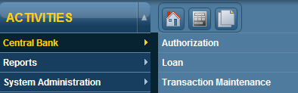

Authorization
The Authorization screen allows you to search for an existing authorization or submit a new authorization request. To get to the Authorization screen, go to Activities → Central Bank → Authorization
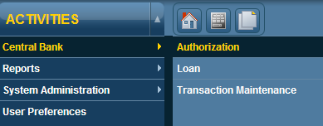
The following screen will appear:
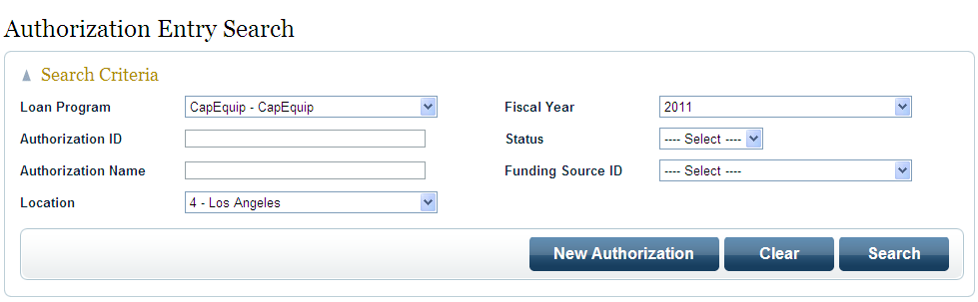

View Authorization
To search for an existing authorization, enter/select your search criteria and click on Search.
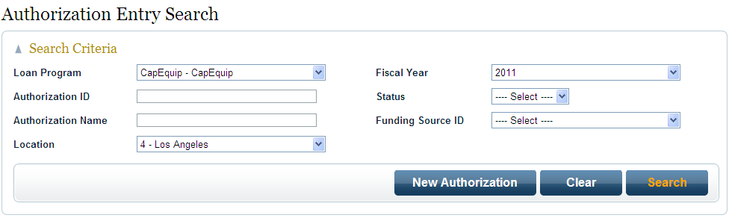
The results of your search will appear under the Authorization Search Results box located toward the bottom of the screen. The Search Criteria box will automatically minimize after search results are displayed. Click on or to maximize or minimize the boxes.
Select an Authorization from the Authorization Search Results box and click on ‘Open’.
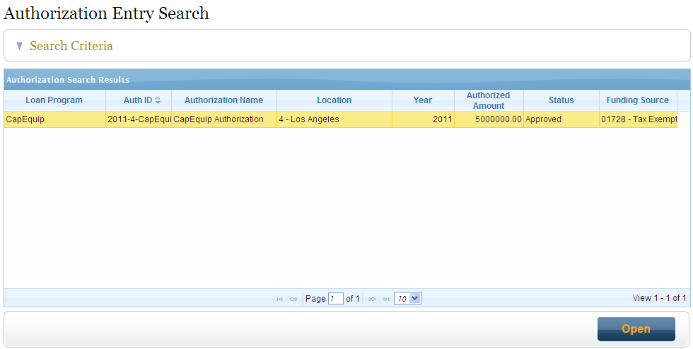

The Authorization Information and Documents are displayed with information on the selected Authorization.
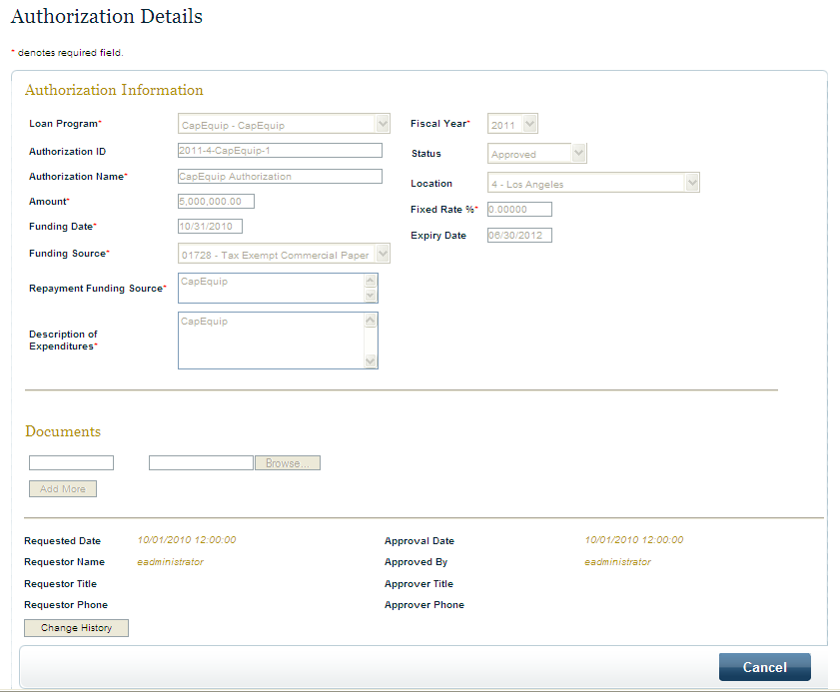

Approved and pending Authorizations are available online. You may view and edit a pending Authorization request if it is prepared from your location. Approved Authorizations cannot be edited but can be viewed by users from your location as well as UCOP users with Central Bank module access.

Requesting a New Authorization

To request a new Authorization, go to Activities → Central Bank → Authorization.
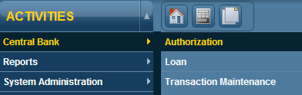

- Click on ‘New Authorization’ on the Authorization Entry Search screen.

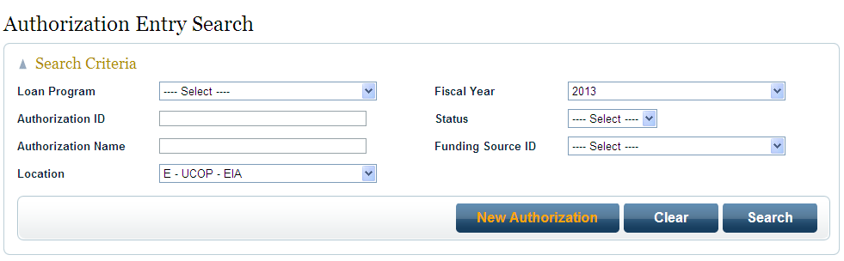

- Enter the required information (indicated with anon the screen):
- The ‘Fixed Rate %’ field is system populated once a Loan Program is selected
- The ‘Funding Source’ field is system populated once a Loan Program is selected
- The ‘Authorization ID’ is generated by the system after the Authorization is submitted.
- Once the ‘Funding Date’ is entered, the ‘Expiry Date’ will auto-populate to 1 year later.
  - For instance, if you entered the ‘Funding Date’ as 10/31/2012, the ‘Expiry Date’ will be 10/31/2013. The user can alter the expiry date.
- Repayment Funding Source is the FAU# or account to be charged interest payments, if applicable
- More than 1 document can be uploaded to the Authorization

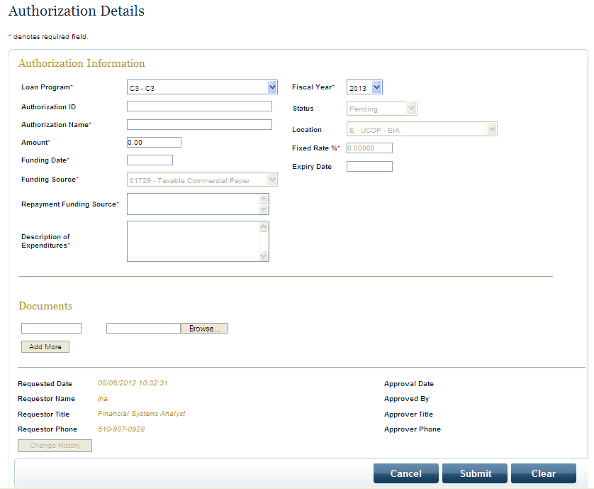

- Once all required fields and documents are uploaded, click Submit. An email notification of regarding this new authorization will be sent to the UCOP approver.

- The UCOP approver will either:
  - Approve the Authorization – the following email notification will be sent to you to notify you that the Authorization was approved.

Subject: EIAOnline Central Bank Authorization ID 2013-4-CapEquip-2 Approved

*** PLEASE DO NOT REPLY TO THIS EMAIL. THIS EMAIL HAS BEEN AUTOMATICALLY GENERATED BY THE EIAONLINE SYSTEM ***

Authorization has been approved.
To view the approved authorization, please log into EIAOnline (https://eiasqa.ucop.edu/eias).

EIAOnline Central Bank Authorization ID 2013-4-CapEquip-2 Test Campus Authorization #2

For further assistance or information about EIAOnline, please send an email to eia@ucop.edu.

Thank you.

  - Reject the Authorization – an email notification will be sent to you to notify you that the Authorization is rejected and the reasons for the rejection.

Subject: EIAOnline Central Bank Authorization ID 2013-4-C3-1 Rejected

*** PLEASE DO NOT REPLY TO THIS EMAIL. THIS EMAIL HAS BEEN AUTOMATICALLY GENERATED BY THE EIAONLINE SYSTEM ***

Authorization has been rejected.
Please log into EIAOnline (https://eiasqa.ucop.edu/eias) and go to Activities/Central Bank /Authorizatons to review.

EIAOnline Central Bank Authorization ID 2013-4-C3-1 Test C3 Authorization

Reject Comments: More information needed for the Description of Expenditures.

Rejected By : ayin

For further assistance or information about EIAOnline, please send an email to eia@ucop.edu.

Thank you.

You can go back into the Authorization to make the necessary edits and submit the authorization for approval.

Loans
The Loan screen allows you to search for an existing loan or submit a new loan request. To get to the Loan screen, go to Activities → Central Bank → Loan
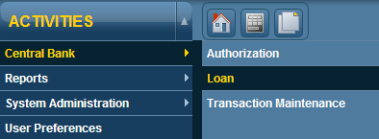
The following screen will appear:
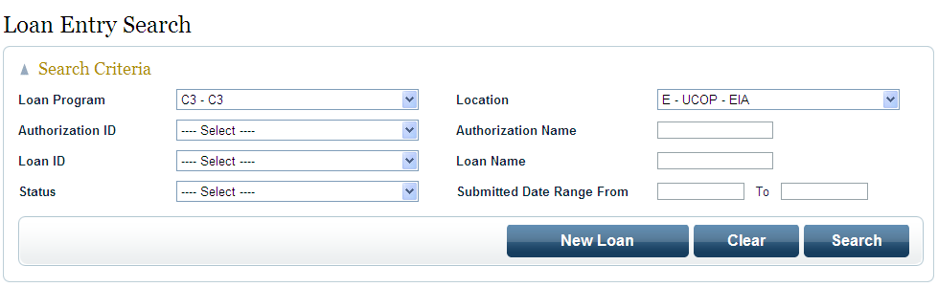

View Existing Loans
To search for an existing loan, enter/select your search criteria and click on Search.
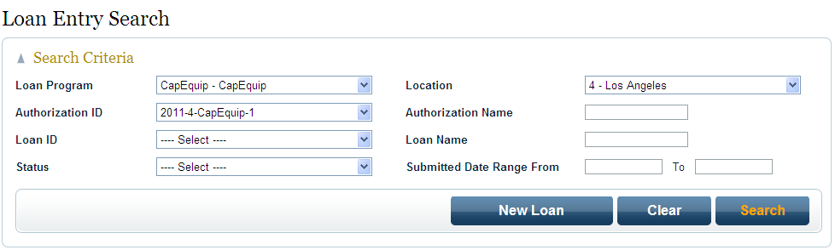
The results of your search will appear under the Loan Search Results box located toward the bottom of the screen. The Search Criteria box will automatically minimize after search results are displayed. Click on or to maximize or minimize the boxes.
Select a Loan from the Loan Search Results box and click on ‘Open’.
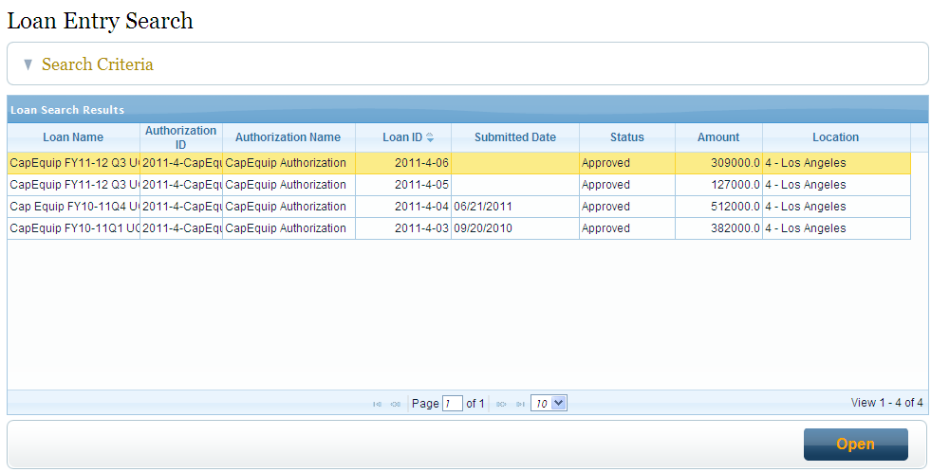

The Loan Information and Documents are displayed with information on the selected Loan.
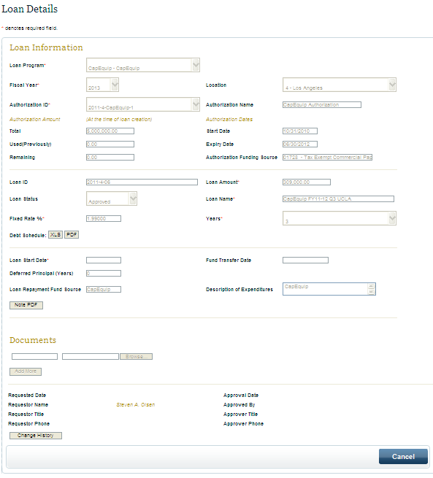

Approved and pending Loans are available online. You may view and edit a pending Loan request if it is prepared from your location. Approved Loans cannot be edited but can be viewed by users from your location as well as UCOP users with Central Bank module access.

Requesting a New Loan

To request a new Loan, go to Activities → Central Bank → Loan.

- Click on ‘New Loan’ on the Authorization Entry Search screen.

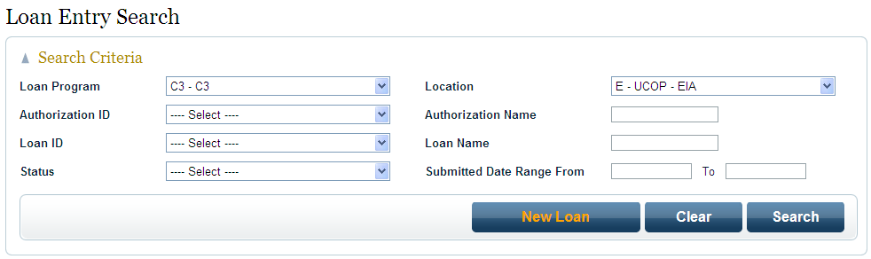

- Enter the required information (indicated with anon the screen):
- User is required to fill out the following 7 fields:
  - Loan Program
  - Fiscal Year
  - Authorization ID
  - Loan Amount
  - Loan Name
  - Years
  - Loan Start Date
- Once Loan Program is selected, the ‘Fixed Rate %’ field is system generated
- Once the Authorization ID is selected in the dropdown list, the Authorization Name, Authorization Amounts (‘Total’, ‘Used (Previously)’ and ‘Remaining’ fields) are system generated).
- After you enter the Loan Start Date, the Fund Transfer Date will be system generated with the next available quarter end date.
  - For instance, if you entered the ‘Loan Start Date’ as 10/31/2012, the ‘Funds Transfer Date’ will be 12/31/2012. Transfer of fund for UC SIP loans occur quarterly.
- Once the information is entered, you can run the Debt Schedule and review:
  - If you select the Debt Schedule XLS button, will appear in excel format. This will only show the debt schedule in excel format and is informational only.

  - If you select the Debt Schedule PDF button, this will generate a PDF file that is informational only.
- Once you’re satisfied with the debt schedule, click on the ‘Note PDF’ button. This will produce a PDF file of the Promissory Note which will include all of the fields that you’ve entered along with the Debt Schedule. This needs to be printed out, reviewed, and signed by the Campus Approver.

- At this time, there is no save function for the loan. If you are unable to upload the Promissory Note document, you can Cancel this loan. After obtaining the Campus Approver signature on the Promissory Note, you will have to create a new loan, enter the information and upload the signed Promissory note under the Documents section and submit for approval.

- The Loan ID is system generated after the Loan is submitted for approval.

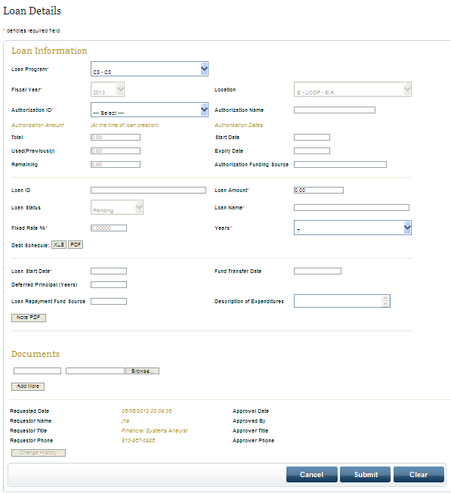

- Once all required fields, signed promissory notes, and other documents are uploaded, click Submit. An email notification of regarding this new loan will be sent to the UCOP approver.

- The UCOP approver will either:
  - Approve the Loan – the following email notification will be sent to you to notify you that the Authorization was approved.

Subject: EIAOnline Central Bank Loan ID 2013-4-3 Approved

*** PLEASE DO NOT REPLY TO THIS EMAIL. THIS EMAIL HAS BEEN AUTOMATICALLY GENERATED BY THE EIAONLINE SYSTEM ***

Loan has been approved.
To view the approved loan, please log into EIAOnline (https://eiasqa.ucop.edu/eias).

EIAOnline Central Bank Loan ID 2013-4-3 Test C3 Loan

For further assistance or information about EIAOnline, please send an email to eia@ucop.edu.

Thank you.

  - Reject the Loan – an email notification will be sent to you to notify you that the Loan is rejected and the reasons for the rejection.

Subject: EIAOnline Central Bank Loan ID 2013-4-3 Rejected

*** PLEASE DO NOT REPLY TO THIS EMAIL. THIS EMAIL HAS BEEN AUTOMATICALLY GENERATED BY THE EIAONLINE SYSTEM ***

Loan has been rejected.
Please log into EIAOnline (https://eiasqa.ucop.edu/eias) and go to Activities/Central Bank /Loans to review.

EIAOnline Central Bank Loan ID 2013-4-3 Test C3 Loan

Reject Comments : Additional documents need to be uploaded to the loan request

Rejected By : jha

For further assistance or information about EIAOnline, please send an email to eia@ucop.edu.

Thank you.

You can go back into the Loan to make the necessary edits and submit the Loan for approval.

- The UCOP approver will upload the most updated promissory note containing the UCOP approver signature (for record keeping) to the approved Loan request.

- The requested amount will be transferred to the campus financial control at the quarter end after Central Bank processing is completed by the UCOP Endowment and Investment Accounting group.

Transactions
The Transaction screen allows you to search for posted transactions or submit a new transaction request. To get to the Transaction screen, go to Activities → Central Bank → Transaction Maintenance
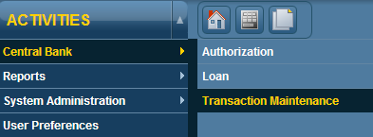
The following screen will appear:
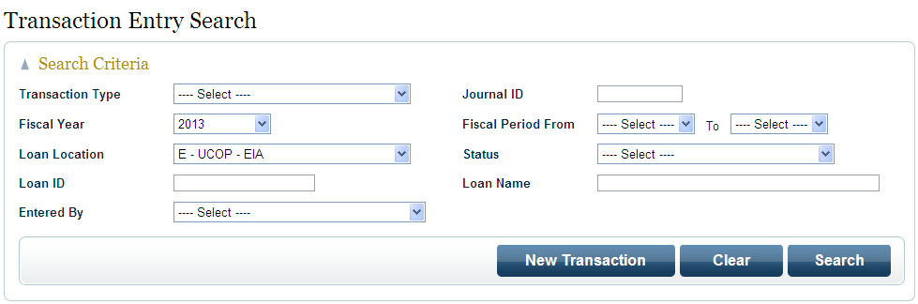

View Transactions
To search for posted transaction, enter/select your search criteria and click on Search.
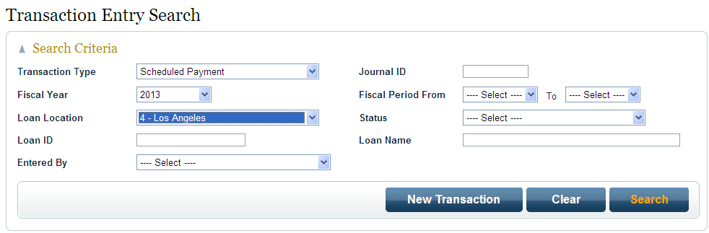
The results of your search will appear under the Transaction Search Results box located toward the bottom of the screen. The Search Criteria box will automatically minimize after search results are displayed. Click on or to maximize or minimize the boxes.
Select a transaction from the Transaction Search Results box and click on ‘Open’.
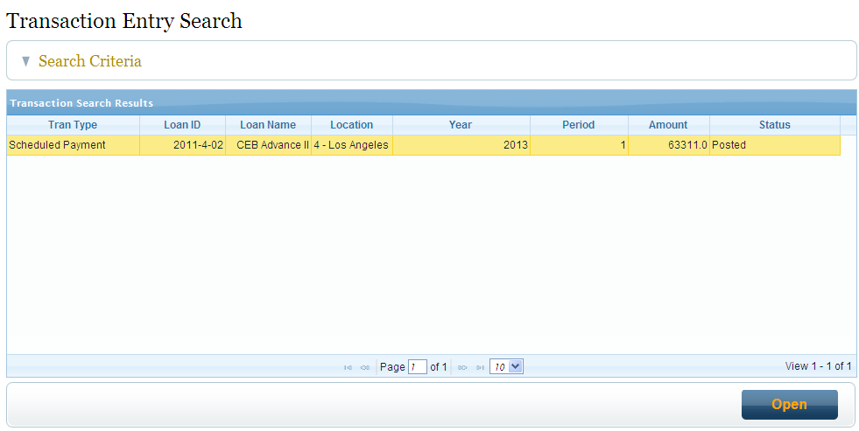

The Transaction Information and Documents are displayed with information on the selected transaction.
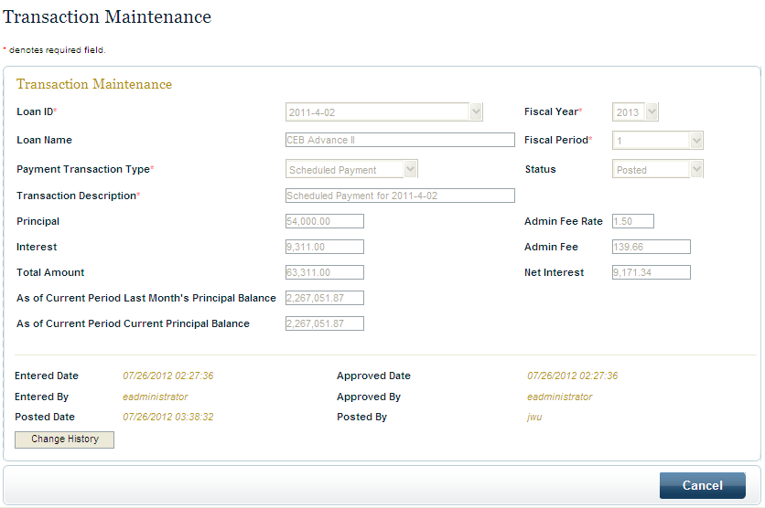

Posted and pending transactions are available online. You may view and edit a pending transaction request if it is prepared from your location. Posted transactions cannot be edited but can be viewed by users from your location as well as UCOP users with Central Bank module access.

Requesting a New Transaction

To request a new Authorization, go to Activities → Central Bank → Transaction Maintenance

- Click on ‘New Transaction’ on the Transaction Entry Search screen.

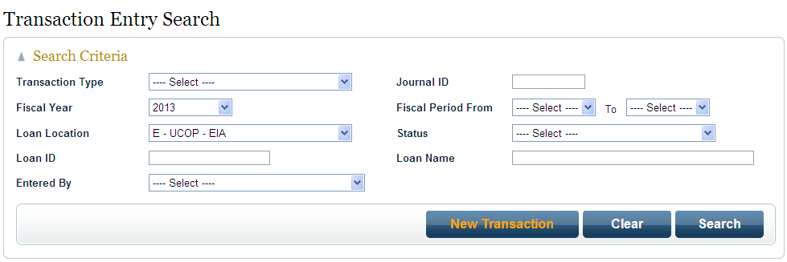

- Enter the required information (indicated with anon the screen):
- User is required to fill out the following 5 fields:
  - Loan ID
  - Fiscal Year
  - Fiscal Period
  - Payment Transaction Type
  - Transaction Description
- Other fields are system generated once the loan ID is selected
- Admin Fee Rate, Admin Fee, and Net Interest are system generated after the transaction is submitted for UCOP approval

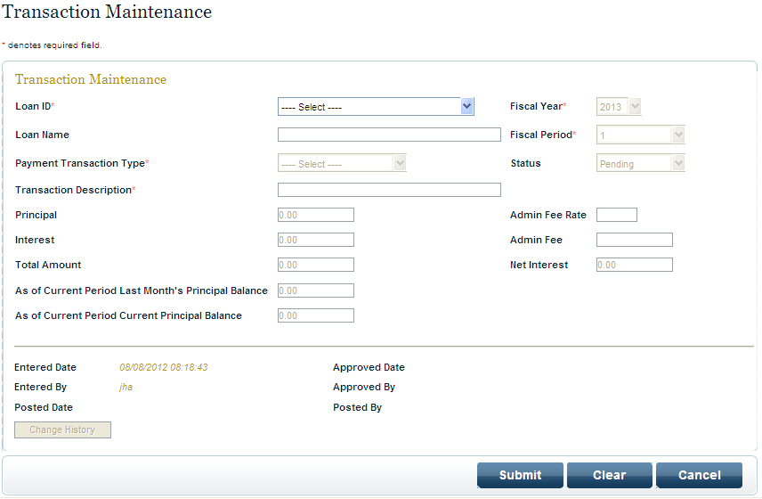

- Once all required fields are entered, click Submit. An email notification of regarding this new transaction will be sent to the UCOP approver.
- Please note that if a Pre-payment transaction request is submitted in a month that is not part of the Loan Program payment schedule, the transaction will be approved and processed in the month that is part of the payment schedule.
- For instance, if a CapEquip pre-payment transaction is submitted in February, the transaction will not be approved and processed until May. Principal and Interest of a CapEquip loan is collected in May.
- Payoff transaction request will be approved and processed in the month that it is submitted.
- The UCOP approver will either:
  - Approve the Transaction – the following email notification will be sent to you to notify you that the Transaction was approved.

Subject: EIAOnline Central Bank Transactions Pre-payment Approved

*** PLEASE DO NOT REPLY TO THIS EMAIL. THIS EMAIL HAS BEEN AUTOMATICALLY GENERATED BY THE EIAONLINE SYSTEM ***

Transaction has been approved.
To view the approved transaction, please log into EIAOnline (https://eiasqa.ucop.edu/eias).

EIAOnline Central Bank Transactions Pre-payment

For further assistance or information about EIAOnline, please send an email to eia@ucop.edu.

Thank you.

  - Reject the Transaction – an email notification will be sent to you to notify you that the Transaction is rejected and the reasons for the rejection.

Subject: EIAOnline Central Bank Transactions Pre-payment Rejected

*** PLEASE DO NOT REPLY TO THIS EMAIL. THIS EMAIL HAS BEEN AUTOMATICALLY GENERATED BY THE EIAONLINE SYSTEM ***

Transaction has been rejected.
Please log into EIAOnline (https://eiasqa.ucop.edu/eias) and go to Activities/Central Bank /Transaction Maintenance to review.

EIAOnline Central Bank Transactions Pre-payment

Reject Comments : correct description

Rejected By : ayin

For further assistance or information about EIAOnline, please send an email to eia@ucop.edu.

Thank you.

You can go back into the Transaction to make the necessary edits and submit the authorization for approval.

Reports
There are three Central Bank reports available for users to run.
To get to the Reports screen, go to Activities → Reports → Central Bank → Authorization
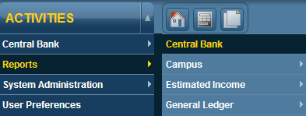
The following screen will appear:
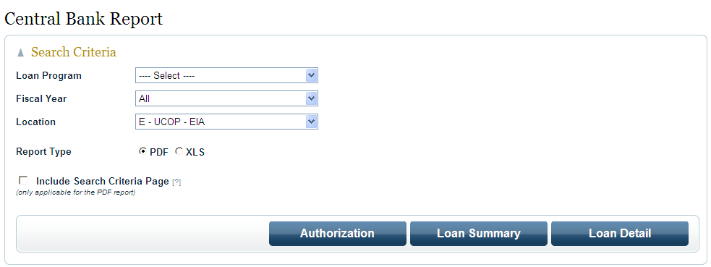

View Reports
To view reports, enter/select your search criteria and click on one of the three reports that will generate a PDF file:
- Authorization Report
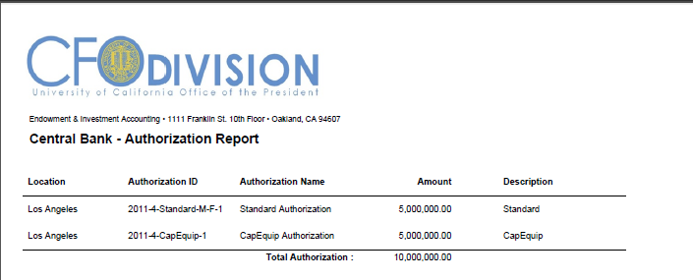

- Loan Summary Report
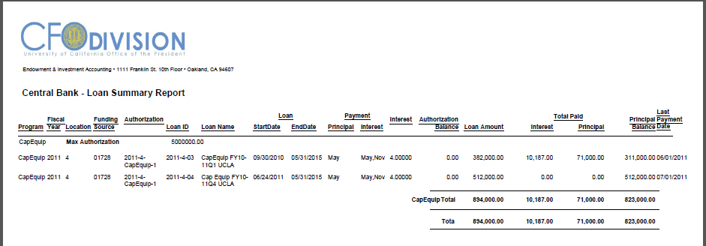

- Loan Detail Report
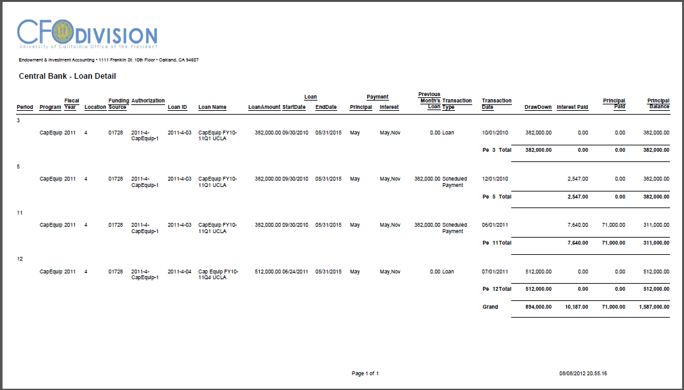

*****End of Document*****

